IBM® Emptoris® Contract Management Advanced Reporting guide

This guide contains information about how tables are joined together and other advanced topics for experienced Cognos report developers using IBM® Emptoris® Contract Management Reporting. Version 1 January 2015
  - Report Developer
IBM® EMPTORIS® CONTRACT MANAGEMENT 10.0.2.6

What this guide contains
IBM® Emptoris® Contract Management uses IBM Cognos® Business Intelligence Platform for reporting. This document contains information regarding the underlying database structure used by the IBM Cognos® Business Intelligence Platform tool framework manager. This guide also contains information on advanced reporting concepts.

Do not use this document if your setup does not contain IBM® Emptoris® Contract Management, or you do not intend to use reporting for IBM® Emptoris® Contract Management.

Audience
This guide is meant for advanced report writers and data modelers who are looking for more information on the underlying reporting data base logical model. To fully understand this document the reader should have experience with IBM® Emptoris® Contract Management and IBM Cognos® Business Intelligence. It would also be helpful to have an understanding of star schemas and modeling for dimensional data.

Disclaimer
This is intended as an overview document of how the database table structure in relation to the framework manager model is used in IBM® Emptoris® Contract Management Reporting. The database tables do not represent the fully executed model for reporting since much of the business logic is captured in the IBM Cognos® Business Intelligence Platform tool framework manager model. This tool is not included as part of the basic reporting delivery.
The database tables are not designed to be reported off of directly.
The following paragraph does not apply to the United Kingdom or any other country where such provisions are inconsistent with local law: INTERNATIONAL BUSINESS MACHINES CORPORATION PROVIDES THIS PUBLICATION "AS IS" WITHOUT WARRANTY OF ANY KIND, EITHER EXPRESS OR IMPLIED, INCLUDING, BUT NOT LIMITED TO, THE IMPLIED WARRANTIES OF NON-INFRINGEMENT, MERCHANTABILITY OR FITNESS FOR A PARTICULAR PURPOSE. Some states do not allow disclaimer of express or implied warranties in certain transactions, therefore, this statement may not apply to you.
This information could include technical inaccuracies or typographical errors. Changes are periodically made to the information herein; these changes will be incorporated in new editions of the publication. IBM may make improvements and/or changes in the product(s) and/or the program(s) described in this publication at any time without notice. IBM may, without notice to you, at any time revise these table structures. IBM may also make improvements or changes in the products, services, or programs described in this document at any time without notice.
This document and all content in this document may not be copied, reproduced, republished, uploaded, posted, transmitted, distributed, or used for the creation of derivative works without IBM's prior written consent, except that IBM grants you non-exclusive, non-transferable, limited permission to access and display the document, solely on your computer and for your personal, non-commercial use. This permission is conditioned on your not modifying the content, your keeping intact all copyright, trademark, and other proprietary notices, and your acceptance of any terms, conditions, and notices accompanying the content or otherwise set forth in this document.
There are some items to be aware of when looking directly at the database tables as these tables do not represent the full data model used in the reporting solution.
The basic database model is enhanced with business rules and security via the IBM Cognos® Business Intelligence Platform framework manager tool (not included in the basic reporting license provided with the IBM® Emptoris® Contract Management application).
The Date fields in the model are stored in the time zone of the server and converted to the time zone of the user in the Cognos model using a database function. The function name is ‘TO_USERTIMEZONE’. This conversion occurs in the Cognos model.
Table and item names in the Database layer are not the exact names displayed for report authors. These names are modified in the IBM Cognos® Business Intelligence Platform tool framework manager.
Security tables are included in the database model. These tables link permissions to read data to the specific ids that the user is authorized to see. The SQL generated by the reporting tool includes this security imbedded in the reporting model that links the security tables to the secured objects. The security matches security in the IBM® Emptoris® Contract Management system. The general rule of thumb is that if you can see the information in contract management you should be able to see it in reporting.
Item name / folder name translations are handled in the IBM Cognos® Business Intelligence Platform framework manager model. Data value translations for internal code tables are handled though linked tables suffixed with ‘_I18N’. Fields that can be modified by a user of the IBM® Emptoris® Contract Management system are only stored in the language entered into the field by the user.
Fields that are stored as more than 1000 characters in the IBM® EMPTORIS® CONTRACT MANAGEMENT database are truncated to 1000 characters in the reporting database.
The core model described in this document is for the use of the IBM® Emptoris® Contract Management reporting team and is intended for delivering the IBM® Emptoris® Contract Management reporting solution via the IBM Cognos® Business Intelligence Platform. Changes to this model are not announced in advance.
IBM may, without notice to you, at any time revise these table structures. IBM may also make improvements or changes in the products, services, or programs described in this document at any time without notice.
This guide was developed as part of the IBM® EMPTORIS® CONTRACT MANAGEMENT 10.0.2.5 release. Some features may not be available in previous versions of IBM® EMPTORIS® CONTRACT MANAGEMENT.

IBM® Emptoris® Contract Management Advanced Reporting guide 0
Review of reporting. 9
Reporting Portal 11
Reporting Tools: Report Studio 12
Reporting Tools: Report Studio Active reports 13
Enabling the Mobile Workforce 13
Managed Dashboards 13
Extending BI to External Customers or Partners 13
Reporting Tools: New Tools 14
Reporting Tools: Workspace Advanced 14
Reporting Tools: Workspace 15
Reviewing the Data Structure 17
The reporting presentation layer a summary. 17
Review of database logical Model a summary 22
Contract Fact Table 23
Review of database logical model table contract fact details 28
Contract Dimensions 29
CONTRACT_ID 29
CONTRACT_TEMPLATE_ID 29
CREATED_FROM_CONTRACT_ID (Links to an alias of the contract template table) 29
CONTRACT_CLASS_ID 29
CONTRACT_STATUS_ID 30
CONTRACT_SUBSTATUS_ID 30
CONTRACT_NATURE_ID 30
CURRENCY_ID 31
CONTRACT_ORIGIN_ID 31
REGION_ID 31
CONTRACT_ORIGIN_VARIANT_ID 32
CONTRACT_TIMEZONE_ID 32
Links to alias of Date Time Dimension 32
Links to alias of Organization Dimension 34
INTERNAL_PRIMARY_INDV_ID (alias links to Primary internal individual with Primary Phone and Address) 35
EXTERNAL_PRIMARY_INDV_ID (alias links to Primary external individual with Primary Phone and Address) 36
NEGOTIATION_STATUS_ID 36
APPROVAL_STATUS_ID 37
IS_AMENDED_BOOLEAN_ID (links to alias of Boolean) 37
CREATED_BY_INDV_ID 37
LAST_MODIFIED_BY_INDV_ID 37
INTERVIEW_ID 38
INTERVIEW_TEMPLATE_ID 38
CONVERTED_BY_INDV_ID 38
CONTRACT_STATE_ID 38
EXECUTION_TYPE_ID 39
TERMINATION_REASON_ID 39
IS_CREATED_FROM_TEMPLATE 39
Additional data groupings 40
Contract Template 41
Clause Template 42
Individuals 43
External Company 45
My Company Organization 45
Approval Rule Set 47
Products 49
Additional fact tables included in the basic Contracts model 51
Affiliated Orgs - Alias of Contract_organization_fact 52
Custom Properties 53
Contract External Party 55
Contract Internal Party 55
Contract Clause 56
Contract Term 57
Contract Attachments 59
Contract Activity 61
Contract Workflow 62
Contract Events 63
Contract Relationship 66
Contract Substatus 67
Contract Comments 69
Contact Task 70
Contract Security 72
Contract Signatories 74
Folders 75
Contract Lines 76
Contract Lines Ext 78
Appendices 80
Appendix A: Term reporting extension table 80
Appendix B: Term Reporting 81
Appendix C: Custom lines 84
Principal design challenge: 84
What changed… 84
Appendix C1: Converting date fields in Contract Lines to user time zones 85
Appendix D: Indexed Fields 86
Appendix E: Large text fields 91
Appendix F: Security 93
Access to reporting Security 93
Row Level Security 93
Class Level Security 95
Appendix G: Date Fields 97
Notices 99

Review of reporting.
IBM® Emptoris® Contract Management ships with Cognos reporting. The IBM® Emptoris® Contract Management reporting module is designed to let you create reports that address specific business questions related to the information contained within the Emptoris contract management system. It is not intended to be used to create a data dump to be transferred to other systems or programs. IBM® Emptoris® Contract Management provides a facility to assist with the transfer of large amounts of data (See the IBM® EMPTORIS® CONTRACT MANAGEMENT Administration Guide for more information).
In general reports are intended to be delivered either via HTML or PDF (although excel, XML, and CSV output is also available). Reports should be created that reasonably fit into this format.
To create an effective report, consider the following points about the report:
- The target audience for the report.
- The business process supported.
- The information that is required to make the business decisions.
- The best way to present the information so that the business user can easily identify the critical information.

Reporting Portal
The Cognos Connection portal opens when you first sign-in to reporting by clicking on the link from Contract Management.
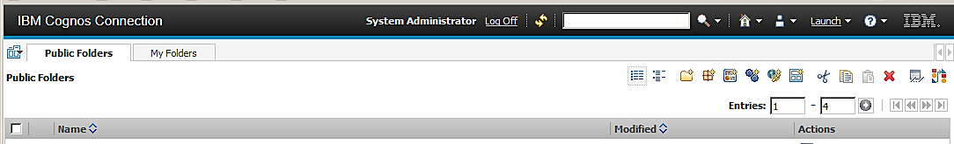
Figure 1 Contract Management reporting starting page
- Cognos Connection allows you to manage Cognos content, schedule / run reports, and launch tools to develop new reports.
- Click Launch to access the reporting tool.
  - Note: Access to reporting tools (Report Studio, Business Workspace Advanced, and Business Workspace) is controlled via roles which limit capabilities within the interface. You must be a member of one of these roles in IBM® EMPTORIS® CONTRACT MANAGEMENT to use reporting (Get list from IBM® EMPTORIS® CONTRACT MANAGEMENT )
- You can access existing content via the two tabs. “Public Folders” and “My Folders”.
- Content is divided into two tabs “My Folders” and “Public Folders”.
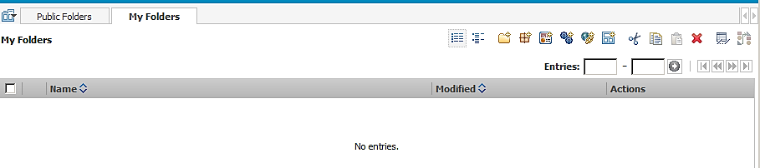
Figure 2 Reporting tabs
  - “My Folders” for content that is just for you
    - My folders content can only be viewed by you and the system administrator.
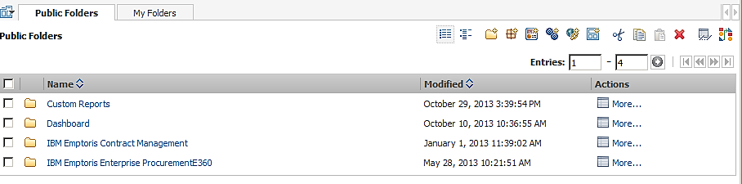
Figure 3 Public folders
  - “Public Folders” for content that is shared between people
    - One Folder for each system delivered by IBM
    - IBM® Emptoris® Contract Management (When installed)
    - IBM® Emptoris® Spend (When installed)
    - Additional Folders can be created by the customer to further control access to reports.
    - Public Folders content is controlled via roles which limit visibility of folders. By default, for Contract Management you will have the IBM® EMPTORIS® CONTRACT MANAGEMENT folder.

Reporting Tools: Report Studio
Intended Audience is for professional report developer
Most Complex and most feature rich report creation tool
This is the tool most users end up using in the long run as it provides the most capabilities. Report Studio has a slightly higher learning curve in initial use. For this advanced report writer this is the tool of choice. Report studio also includes the ability to create active reports (see next section).
Report studio can be started in the following three ways:
- From the Launch menu in IBM Cognos Connection
- From the Welcome page (Author Business Reports) to create new reports or edit existing reports.
- From an existing report by clicking on the Report Studio icon

Reporting Tools: Report Studio Active reports
“The features of IBM Cognos Active Report make it a flexible and portable solution whose benefits can be leveraged across an entire organization and beyond. In order to ensure a successful deployment, it is important to apply the technology to the proper use cases. Some of the ideal use cases for IBM Cognos Active Report include:
- Enabling the Mobile Workforce
- Managed Dashboards
- Extending BI to External Customers or Partners”
IBM Business Analytics Proven Practices: IBM Cognos Active Report 10.2 Cookbook
IBM Business Analytics Proven Practices: IBM Cognos Active Report 10.2 Cookbook

Managed Dashboards
“Business users expect visually appealing, high performance and interactive dashboards that are able to communicate key business information. IBM Cognos Active Report allows the professional report author to create managed dashboards that can be distributed to a broad audience. The wide array of IBM Cognos Active Report controls ensures that the desired functionality can be achieved and an engaging end user experience can be delivered to business users. The reporting applications are high performance stand-alone files and by leveraging drill through technology, business users can seamlessly connect to more detailed data without losing context. “ IBM Business Analytics Proven Practices: IBM Cognos Active Report 10.2 Cookbook

Extending BI to External Customers or Partners
“Businesses can improve their relationships with customers and increase synergies with partners by improving the flow of information to external users. IBM Cognos Active Report technology allows interactive reports to be distributed outside the organization without having to worry about granting those users access to the IBM Cognos server. The solution provides a scalable and secure way of sharing information outside the organization without creating an increased support burden.”
IBM Business Analytics Proven Practices: IBM Cognos Active Report 10.2 Cookbook

Reporting Tools: New Tools
New Tools
- Workspace Advanced
- Workspace
Two product components are renamed in this release to avoid confusion with the names of other components. IBM Cognos Business Insight is now IBM Cognos Workspace. IBM Cognos Business Insight Advanced is now IBM Cognos Workspace Advanced.

Reporting Tools: Workspace Advanced
Intended audience is for business user report writers.

Workspace Advanced is designed to be used by a business user who wants to develop their own reports. This is the most recently rereleased reporting tool which combines features from the other reporting tools. Workspace advanced contains a simpler interface than report studio yet it is fully compatible with Report Studio
- Reports authored in Workspace advanced can be opened and saved in Report Studio
- Reports created in Report Studio can be opened and saved in Workspace advanced.
  - Some Report studio elements cannot be edited in Workspace advanced.

You can open Cognos Workspace Advanced in the following four ways:
- From a workspace in IBM Cognos Workspace to perform advanced editing or to create a new report (Do More)
- From the Launch menu in IBM Cognos Connection
- From the Welcome page (Author Business Reports) to create new reports or edit existing reports.
- From an existing report by clicking on the Workspace Advanced icon

Reporting Tools: Workspace
Intended audience is executive report consumers
“IBM Cognos Workspace is a web-based tool that allows you to use IBM Cognos content and external data sources to build sophisticated interactive workspaces that provide insight and facilitate collaborative decision making.”
Cognos 10.2.1 User Manual
Cognos Workspace is a tool to create dashboards from pre-existing content. Report authors create content and this content can then be used by dashboard creators.

Working with Contracts data
As a report developer you will be using the presentation layer that is exposed to report developers via the reporting tools (Report Studio, Workspace Advanced).

Summary of items that can be confusing.
There are a number of items that can be difficult to work with if you do not understand how they are used and stored in the contract management system. In this section we will review these items and how they are represented in the reporting database
- Custom items
  - Term Definitions
    - Terms as Rows
    - Terms as Columns
    - Term Names as columns truncated at 28 characters
  - User-Defined Properties
  - Custom Properties

Custom items
Each customer can define custom items that are unique to their installation of the Contract Management system. In general these custom items are stored as rows of data in the reporting database.

Term Definitions
Client Term Definitions are created under Administration Term Definitions and then assigned to either contracts or contract templates. There are two types of Terms system and client created. System Terms are pre-supplied with Emptoris Contract Management. System term definitions also include any custom property term definitions created while defining an external organization custom property during the Contract Management set-up process. Client created terms are created by the client administrator to meet the clients individual needs. Client created terms are unique to each installation. Terms assigned to contracts are stored in two ways for reporting.

Terms Assigned to contracts
The terms are found in two folders, under the “Contracts” folder, representing the two different ways we work with terms. The first is the full set of terms both system and client created. In this folder terms are stored as rows with each row representing information about the term. These term definitions stored as rows are located in the “Contract Term” folder under the “Contracts” folder. The second is the list of terms that have the “Available for Reporting” checkbox checked in the Contract Management application. In this folder terms that are marked “Available for Reporting” have been pivoted into columns with one column per term selected (up to 300 terms may be selected). These term definitions stored as columns are located in the “Contract Custom Terms” folder under the “Contracts” folder.
Note: for terms assigned to contracts: Terms are moved to the reporting database by the ETL jobs. The ETL must run before the terms will be visible in reporting. The term values are not visible in reporting until they are assigned to a contract.

Term names truncated at 28 characters when moved to column names in Custom Terms table
Term Label | Term Name | Reporting Name
Global-Strat Sourcing_Sub Category_1 | strat_sourcing_sub_cat_1 | strat_sourcing_sub_cat_1
Global-Strat Sourcing_Sub Category_2 | strat_sourcing_sub_category_2 | strat_sourcing_sub_category_
Global-Strat Sourcing_Sub Category_3 | strat_sourcing_sub_category_3 | strat_sourcing_sub_category_1
For reporting we are writing these names to a column name in the database. We are limited in column name maximum length by the database so we are truncating the column at 28 characters and appending "_" , and if needed <version number>, so that the names will always be unique and fit in the database column length. In this case two of the variables exceeded this length and were truncated. In Addition the term name included an ( _ ) underscore at the end of the name. This can lead to confusing results as in the below example. Our recommendation would be to keep the Term Name as simple and short as possible.

Terms assigned to Contract Templates
Client created terms can be assigned to a contract template. This names of terms assigned to templates can be found in the “Contract template Terms” folder in the “Contract Template” folder. In this folder contract template terms are stored as rows with each row representing information about the term.
Note for terms assigned to templates: The term names are visible if they are assigned to a template. However, the term values are not visible in the terms at the template level.

User-Defined Properties
User defined properties are used in the creation of Custom Properties. They are only available at the Contract template level currently. You can only report on User-Defined Properties as they are assigned to contract templates. The full reporting on User-Defined Properties for contracts is scheduled for a future release.

Custom Properties
Custom Properties are only available at the contract level. Custom Properties are stored as rows of data.

Reviewing the Data Structure

The reporting presentation layer a summary.
As a report developer you will be using the presentation layer that is exposed to report developers via the reporting tools (Report Studio, Workspace Advanced).
As you open the presentation layer folders the first Level shows subject areas that are independent. Data from within them makes sense on their own or combined with other subject areas. The only exception is Approval Rule set which is not linked to any other subject area. 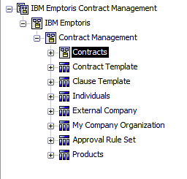
Figure 4 Presentation layer
As you open up the first level query subjects (indicated by this icon ) you will see a set of subfolders. These are data items that make the most sense to display with other data items within that subject area.
The model is built around contracts so contracts are included in their own “Namespace” (indicated by this icon ). The “namespace” in Cognos uniquely identifies items. This is a visual cue that the model centers on this set of objects. In our model “Contracts” is its own “namespace”. Since this is the central item of the model, let’s look at the “Contracts” folder first.
The “Contracts” area has 21 query subjects.
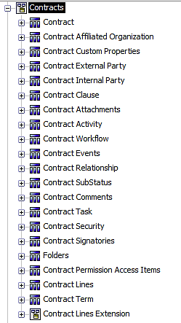
Figure 5 Contracts query subject
The first query subject is contract and contains all the data items that are in a one to one relationship with a contract. There are 52 data items available in this query subject representing all the “Dimensions” or descriptive fields about a contract. You can think of these “Dimensions” as describing who, what, and when of a contract. In addition the query subject has two “Fact” items or “measures”. These are “Contract Total” and “Number of Contracts”. Fact items are used to measure things (How many, how much) and can be rolled up.
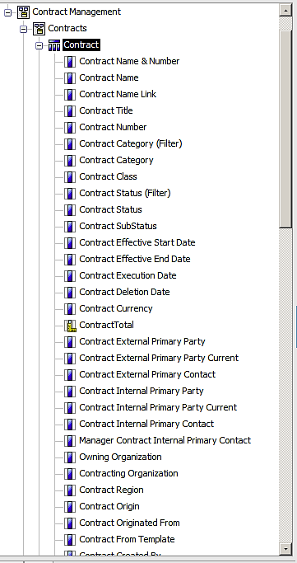
Figure 6 Contract query subject data items (1)
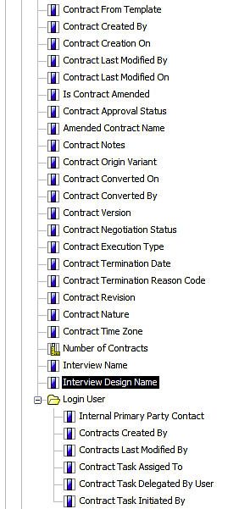
Figure 7 Contract query subject data items (2)
Below the contract query subject each subsequent query subject represents a one to many relationships with a contract. So for example, a contract can have many Affiliated Organizations, Custom Properties, External Party, Internal Party, Clause, Attachments, etc…
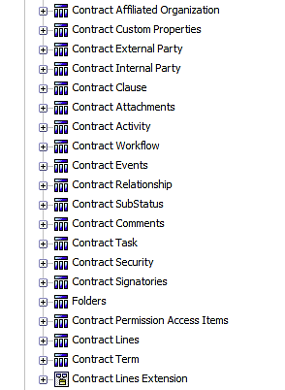
Figure 8 additional query subjects
Each query subject may contain additional subfolders. These subfolders again indicate additional one to many relationships with the folder above it. So for example if you open the “Contract External Party” folder you will see two subfolders “Contract External Party Contact” and “Contract External Party Address”. This tells you that you can have multiple external party contacts and in addition you can have multiple addresses for each external party.
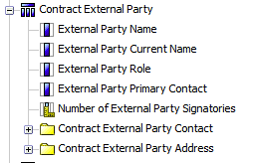
Figure 9 External party query subject
Custom line information for each customer is stored in the “Contract Lines Extension” folder. This folder is generated dynamically and reflects custom fields added by the customer to lines. See Appendix C for more information.
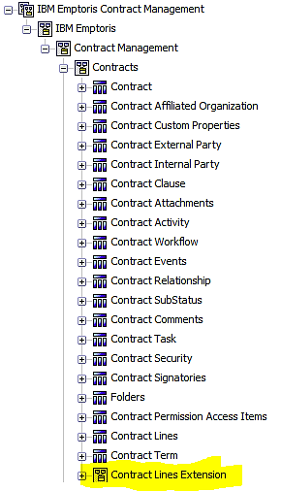
Figure 10 Contract Lines Extension (Line items as columns)
Custom Term information for each customer is stored in the “Contract Terms Extension” folder. This folder is generated dynamically and reflects custom fields added by the customer to Terms. See Appendix A and Appendix B for more information.

Review of database logical Model a summary
This section of the document describes the Database logical model as modeled in Framework manager. This is how the database tables and joins are represented in the database layer of IBM Cognos® Business Intelligence Platform framework manager tool. The database physical model does not directly represent the reporting model. The database model is enhanced with business rules, translations, and security via the IBM Cognos® Business Intelligence Platform framework manager tool (not included in the basic reporting license provided with the IBM® Emptoris® Contract Management application). In addition there is a separate companion document representing the database physical model showing the details of every join used in the model (See the “Joins in the IBM® Emptoris® Contract Management Reporting Data Base Layer document”).
The data from the IBM® Emptoris® Contract Management database has been transformed into a dimensional model optimized for reporting. We have modeled the data as a series of “Fact” and “Dimension” tables. This enables better reporting performance and yields a more understandable data model.
This transformation is accomplished using the ETL tool Data Stage. Using Data Stage we “E” extract the data from Contract Management. Next we “T” transform the data into a relational structure. Finally we “L” load the data into the reporting database.
The heart of the IBM® Emptoris® Contract Management reporting model is the contract. In the reporting model we have set things up so that as soon as you include an item from the contract folder all additional data is brought back associated to a contract.
This is represented in the database layer by the contract fact table. The contract fact table is used to connect the contract with all of the information that is a one to one relationship with the contract. In the diagram below you can see the contract fact in the middle of the diagram with all the “Dimension” tables surrounding it. Each of these “Dimension” tables represents a grouping of data and is linked to the contract fact via a dimensional id number and the contract dimension table is used to link a contract to its dimensions and other fact groupings.

Contract Fact Table
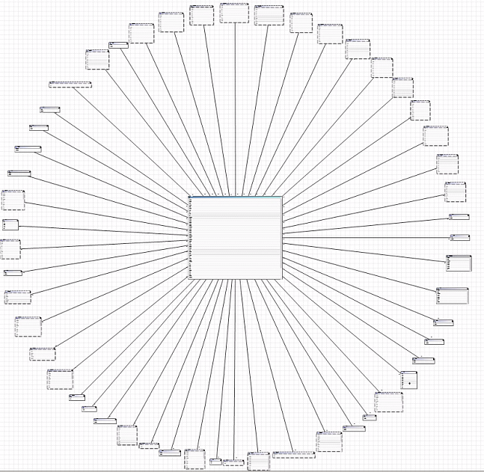
The contact fact table contains information about your contracts. It tracks the total amount of the contract, and the time it took to get the contract through various stages (draft, approval, clause approval, contract approval). It links this information to all the descriptive tables (Dimensions) so that you can answer a wide variety of business questions. This layout is called a star schema. The contract fact table is in the middle with all of the descriptive tables arrayed around it. The contract fact table consists of a series of id fields used to link to the dimensions (descriptive information) and the facts (quantitative data) about your contract. The ids are generated by the reporting ETL process and are not related to the ‘Contract Management’ application. They are not exposed to the report developer at this time.
Figure 11 Contract Fact Star
The fact tables hold the information used to create a ‘count’ or ‘sum’ of information about your contract, answering the business questions about how much, how many, and how long, etc. These items are usually numeric and are referred to as facts. In addition to the fact fields the fact table contains a series of ID fields that are used to link to dimension tables. The dimension tables are used to hold information that describe the contract, answering who created it, what is the contract status, where is the location in which the contract was executed, etc. These dimension tables are linked to the contract fact via an inner join with missing records linking to a record 0 (zero) so that no records are dropped. Currently there are 42 dimension tables.
The contract fact contains the following fact items. These first two items are presented to the report developer in the Contract folder and the other items are presented in the Workflow subfolder under the contracts folder.
- TOTAL_COST from the contract amount
- NUM_CONTRACTS constant always set to 1 used to count number of contracts when grouping.
- DRAFT_DURATION(calculated)
- APPROVAL_DURATION (calculated)
- CLAUSE_APPROVAL_DURATION (calculated)
- CONTRACT_APPROVAL_DURATION (calculated)
- INTERNAL_NEGOTIATION_DURATION (calculated)
- EXTERNAL_NEGOTIATION_DURATION (Calculated)
- CREATION_TO_EXEC_DURATION (Calculated)
- NUM_CONTRACT_APPRV_PROCESSES (Calculated)
- NUM_CLAUSE_APPRV_PROCESSES (Calculated)
- NUM_EXTERNAL_NEGOTIATIONS (Calculated)
The contract fact table links to 42 dimension tables, each one describing a different aspect of the contract. Some tables are maintained internal to the application, and therefore link to a fixed translation table with suffix I18N. The I18N tables have a ‘locale’ field that contains a code representing the languages that the field has been translated into. The second field appends a prefix of ‘local_’ to the original field name. In the reporting model, the tables are filtered based on the language associated to the login of the user and then use the ‘local_’ field value for display. This results in a single record being returned with the value of the field changing to the local language of the user when the report is run. One example of this is in the contract status table.
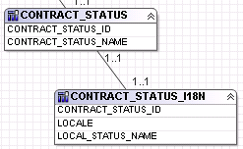
Figure 12 Translation table structure
Since these item values change (to the appropriate local language equivalent) each time the language of the user changes, they are not reliable for creating filters or calculations that have to be evaluated. In these cases the data item is included twice. The first item is the standard data item; it is followed by a ‘(filter)’ version that is always in English. Using the same example from above of contract status, two items are available. ‘Contract Status (Filter)’ is the English-only version which should be used to create calculations that need to be evaluated and filters. The data item ‘Contract Status’ is used for displaying the value in the appropriate language.
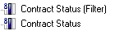
Figure 13 Translated items for filtering and reporting
All tables are fetched using ‘select * from [IBMConnection].<Reporting Database Table Name>’. This allows Cognos to use its minimized SQL feature. In practice this results in only the data items used in the report being included in the query.
[IBMConnection] is a placeholder that is replaced with the database connection information provided on the administrative console of the reporting application for the connection named ‘IBMConnection’ at run time. The set-up of [IBMConnection] connection information is done as part of the normal installation and configuration of the IBM® Emptoris® Contract Management reporting system.
The information in these dimension tables are used to populate the presentation layer contract folder that is displayed for report authors in the reporting tools.
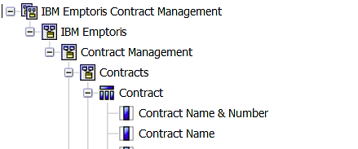
Figure 14 Presentation layer structure
In addition to the basic dimensions there are 20 additional fact tables that are linked to contract through the Contract Dimension. These tables represent one to many linkages to the contract.

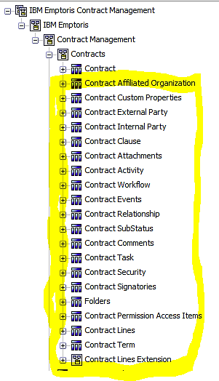
Figure 15 Additional fact groupings
These tables are used to populate the data items in the folders underneath the ‘contract’ folder in the report authoring tools. Each one of these folders represents data that can be repeated many times for each contract.
For example, a contract can have multiple clauses associated with it. The linkage between multiple clauses and contract is tracked in the contract_clause_fact table with an outer join between the contract dimension and the contract_clause_fact table. So if you select the field ‘Contract Name & Number’ and add it to a report you will get one row of data per contract. This will be true for any item you add from the contract folder. These items can be combined in any way and you will still only get one row of data per contract.
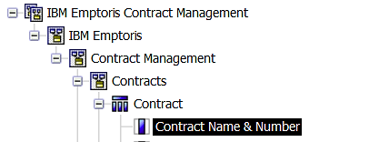
Figure 16 Data items in Contract fact table
If you then go to the clause folder (indicating a one to many relationship) and add ‘Clause Name’ you will get many rows per contract, each line representing a clause for that contract. The data from the ‘Contract’ folder will be repeated on each clause line with only the clause name changing until all clause rows have been displayed.
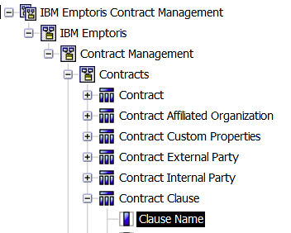
Figure 17 Data items in clause fact table

(See the following section entitled “Additional Facts included in the Contract Data Grouping” for a listing of these 20 additional fact tables)

Review of database logical model table contract fact details

This list of tables represents the core dimension of the IBM® Emptoris® Contract Management contract fact model. The following sections will list the ID fields from the contract fact table and the dimension table the ID field links to.
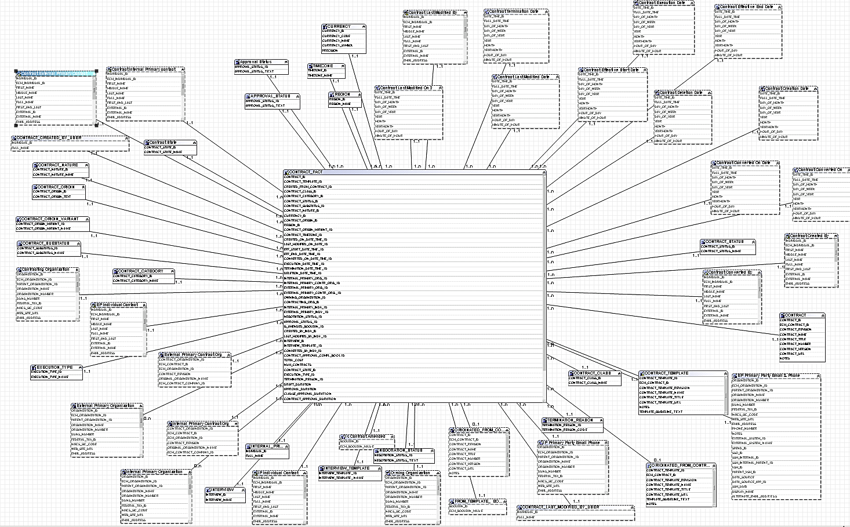
Figure 18 Contract fact table with dimensions
Each ID in the fact table is linked in a one to many relationship with corresponding dimension tables. The Dimension tables contain the details about that dimension. In the presentation layer that is available to report developers we only show the descriptive fields and not the ID’s. All ID fields are indexed to provide fast access to the model. In addition see Appendix D for a full list of all indexed non-id fields.
The following section contains a list of all the contract dimensions and how they are connected to the contract fact table. The table fields are listed along with the table name from the database for reference.
Joins to dimensional tables are all inner joins. Missing dimensional information is represented by a link to a record “0” to prevent data from being dropped by the model.

Contract Dimensions

CONTRACT_ID
Select * From [IBM Connection].CONTRACT

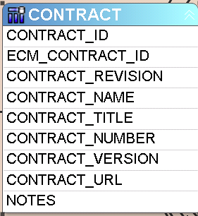
Figure 19 Contract dimension

CONTRACT_TEMPLATE_ID
Select * from [IBM Connection].CONTRACT_TEMPLATE
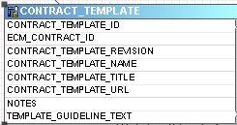
Figure 20 Contract template dimension

CREATED_FROM_CONTRACT_ID (Links to an alias of the contract template table)
Select * from [IBM Connection].CONTRACT_TEMPLATE
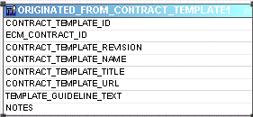
Figure 21 Contract created from dimension

CONTRACT_CLASS_ID
Select * from [IBM Connection].CONTRACT_CLASS
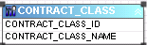
Figure 22 Contract class dimension

CONTRACT_STATUS_ID
(This is an IBM® Emptoris® Contract Management standard field so it has an attached translation table with the I18N suffix. The value from the I18N table [value in local language of the user] is presented as the field and will change based on the local language of the user running the report and the untranslated version is presented with a suffix of “(Filter)”).
Select * from [IBM Connection].CONTRACT_STATUS
Select * from [IBM Connection].CONTRACT_STATUS_I18N
Figure 23 Contract status dimension

CONTRACT_SUBSTATUS_ID
Select * from [IBM Connection].CONTRACT_SUBSTATUS
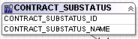
Figure 24 Contract sub-status dimension

CONTRACT_NATURE_ID
Select * from [IBM Connection].CONTRACT_NATURE
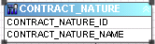
Figure 25 Contract nature dimension

CURRENCY_ID
Select * from [IBM Connection].CURRENCY
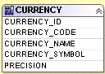
Figure 26 Contract currency dimension

CONTRACT_ORIGIN_ID
(This is an IBM® Emptoris® Contract Management standard field so it has an attached translation table with the I18N suffix. The value from the I18N table [value in local language of the user] is presented as the field and will change based on the local language of the user running the report and the untranslated version is presented with a suffix of “(Filter)”)
Select * from [IBM Connection].CONTRACT_ORIGIN
Select * from [IBM Connection].CONTRACT_ORIGIN_I18N
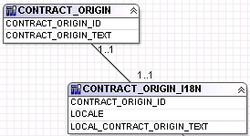
Figure 27 Contract origin dimension

REGION_ID
Select * from [IBM Connection].REGION
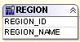
Figure 28 Contract region dimension

CONTRACT_ORIGIN_VARIANT_ID
Select * from [IBM Connection].CONTRACT_ORIGIN_VARIANT
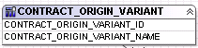
Figure 29 Contract origin variant dimension

CONTRACT_TIMEZONE_ID
Select * from [IBM Connection].TIMEZONE
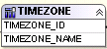
Figure 30 Contract timezone dimension

Links to alias of Date Time Dimension

CREATED_ON_DATE_TIME_ID

LAST_MODIFIED_ON_DATE_ID

EFF_START_DATE_TIME_ID

EFF_END_DATE_TIME_ID

CONVERTED_ON_DATE_TIME_ID

EXECUTION_DATE_TIME_ID

TERMINATION_DATE_TIME_ID

DELETION_DATE_TIME_ID

Select * from [IBM Connection].DATE_TIME
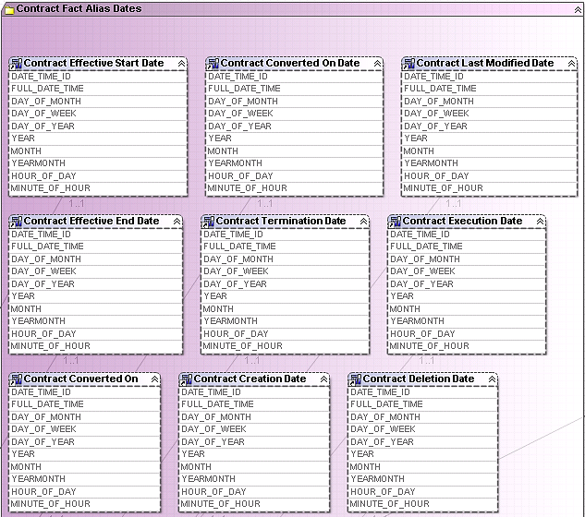
Figure 31 Contract dates

Links to alias of Organization Dimension

INTERNAL_PRIMARY_ORG_ID

INTERNAL_PRIMARY_CONTR_ORG_ID

EXTERNAL_PRIMARY_ORG_ID

EXTERNAL_PRIMARY_CONTR_ORG_ID

OWNING_ORGANIZATION_ID

CONTRACTING_ORG_ID

Select * from [IBM Connection].ORGANIZATION
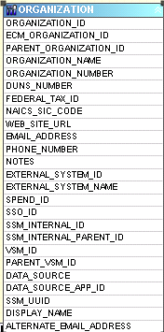
Figure 32 Organization dimension

INTERNAL_PRIMARY_INDV_ID (alias links to Primary internal individual with Primary Phone and Address)
Select * from [IBM Connection].INDIVIDUAL
Select * from [IBM Connection].INDIVIDUAL_ADDRESS
Select * from [IBM Connection].INDIVIDUAL_PHONE
Select * from [IBM Connection]."BOOLEAN"
Select * from [IBM Connection].BOOLEAN_I18N (This is an IBM® Emptoris® Contract Management standard field so it has an attached translation table with the I18N suffix. The value from the I18N table [value in local language of the user] is presented as the field and will change based on the local language of the user running the report and the untranslated version is presented with a suffix of “(Filter)”)
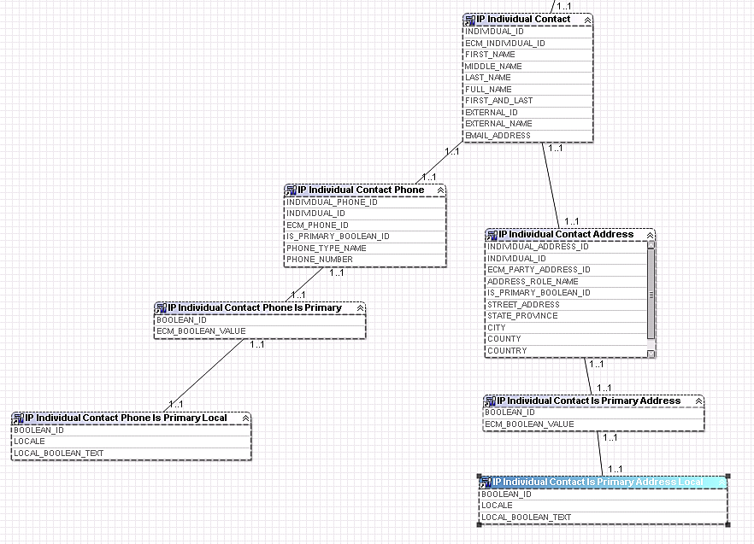
Figure 33 Individual dimension

EXTERNAL_PRIMARY_INDV_ID (alias links to Primary external individual with Primary Phone and Address)
Select * from [IBM Connection].INDIVIDUAL
Select * from [IBM Connection].INDIVIDUAL_ADDRESS
Select * from [IBM Connection].INDIVIDUAL_PHONE
Select * from [IBM Connection]."BOOLEAN"
Select * from [IBM Connection].BOOLEAN_I18N (This is an IBM® Emptoris® Contract Management standard field so it has an attached translation table with the I18N suffix. The value from the I18N table [value in local language of the user] is presented as the field and will change based on the local language of the user running the report and the untranslated version is presented with a suffix of “(Filter)”)
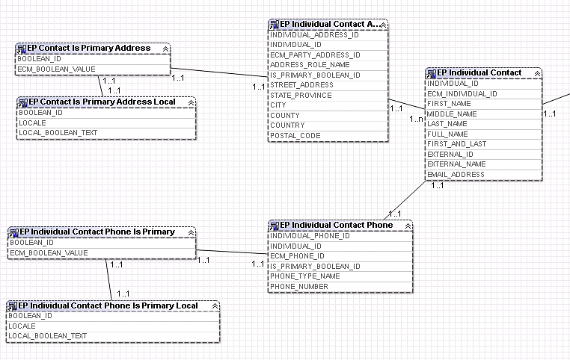
Figure 34 External primary contact

NEGOTIATION_STATUS_ID
Select * from [IBM Connection].NEGOTIATION_STATUS
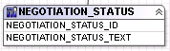
Figure 35 Contract Negotiation Status

APPROVAL_STATUS_ID
Select * from [IBM Connection].APPROVAL_STATUS
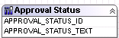
Figure 36 Contract approval status

IS_AMENDED_BOOLEAN_ID (links to alias of Boolean)
Select * from [IBM Connection]."BOOLEAN"
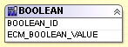
Figure 37 Boolean

CREATED_BY_INDV_ID
Select INDIVIDUAL.FULL_NAME, INDIVIDUAL.INDIVIDUAL_ID from INDIVIDUAL
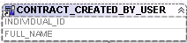
Figure 38 Contract created by dimension

LAST_MODIFIED_BY_INDV_ID
Select INDIVIDUAL.FULL_NAME, INDIVIDUAL.INDIVIDUAL_ID from INDIVIDUAL
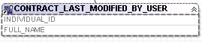
Figure 39 Contract modified by dimension

INTERVIEW_ID
Select * from [IBM Connection].INTERVIEW
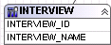
Figure 40 Contract interview dimension

INTERVIEW_TEMPLATE_ID
Select * from [IBM Connection].INTERVIEW_TEMPLATE
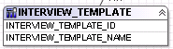
Figure 41 Contract interview template dmension

CONVERTED_BY_INDV_ID
Select * from [IBM Connection].INDIVIDUAL
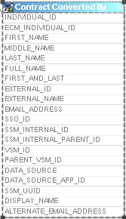
Figure 42 Contract converted by dimension

CONTRACT_STATE_ID
Select * from [IBM Connection].CONTRACT_STATE
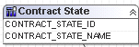
Figure 43 Contract state dimension

EXECUTION_TYPE_ID
Select * from [IBM Connection].EXECUTION_TYPE
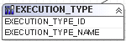
Figure 44 Contract execution state dimension

TERMINATION_REASON_ID
Select * from [IBM Connection].TERMINATION_REASON
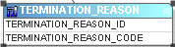
Figure 45 Contract termination reason dimension

IS_CREATED_FROM_TEMPLATE
Select * from [IBM Connection]."BOOLEAN"
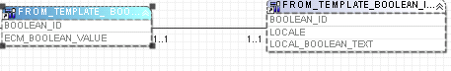
Figure 46 Contract created from template dimension

Additional data groupings
In addition to the contract fact and its associated dimensions we have included seven additional groups of data that can be queried independently of contract.
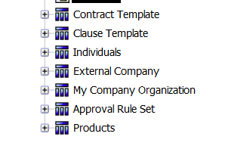
Figure 47 Independent subject areas
This is done to facilitate searches which are not contract centered. For example, if you wanted to see the primary external contact for a particular contract you would start in the contracts folder and use the “primary external contact” data item. However if you want a list of all external contacts you would go to the individuals table since this table represents all individuals created in the contract management system. The contract query subject contains the primary contact while the individuals table contains all contacts.
Another example is the Contract Template folder. The contract template folder contains records for all templates created in the contract management system. The contract template data item in the “contract” query subject only contains those templates that have been associated with a contract.

Contract Template
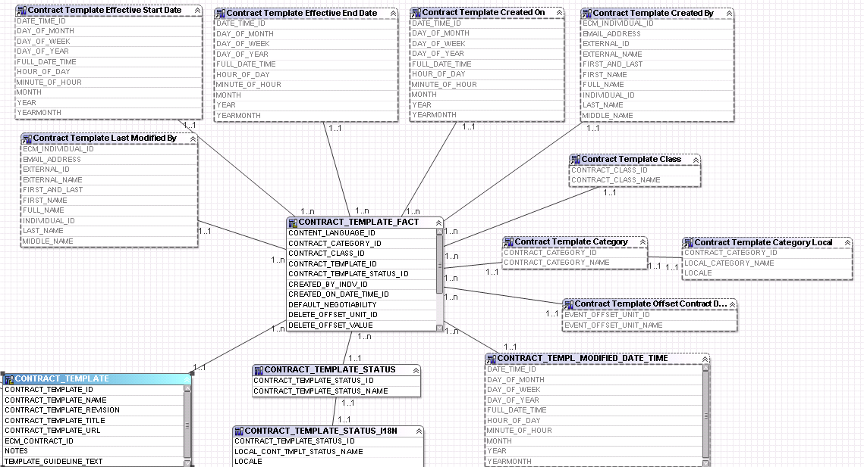
The contract template fact table contains information about the templates you have created. It tracks all the templates you have created in the IBM® Emptoris® Contract Management system.
Figure 48 Contract Template Database layer
Dimensions are linked to the fact table via an inner join. Missing dimensional information is represented by a link to a record “0” to prevent data from being dropped by the model.

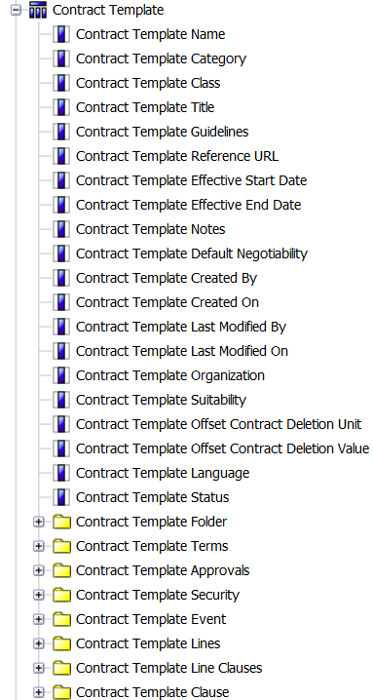
In the Cognos presentation (reporting) layer it is set up very similar to contracts. The first set of items is all at the contract template level and result in one row of data per contract template.
Figure 49 Contract Template
These items correspond to the items that are in the contract record when it is created from this template. So just like a contract, a contract template has one category, class, title, etc…
These data items are followed by 8 folders. The folders represent data that is in a ‘one to many’ relationship with the contract template. Adding data items from these folders will return multiple rows of data per contract template. So just like a contract a contract template can have multiple default folders, default terms, default approvals, etc…

Each of the folders contains multiple data items associated with this subject area.

Clause Template
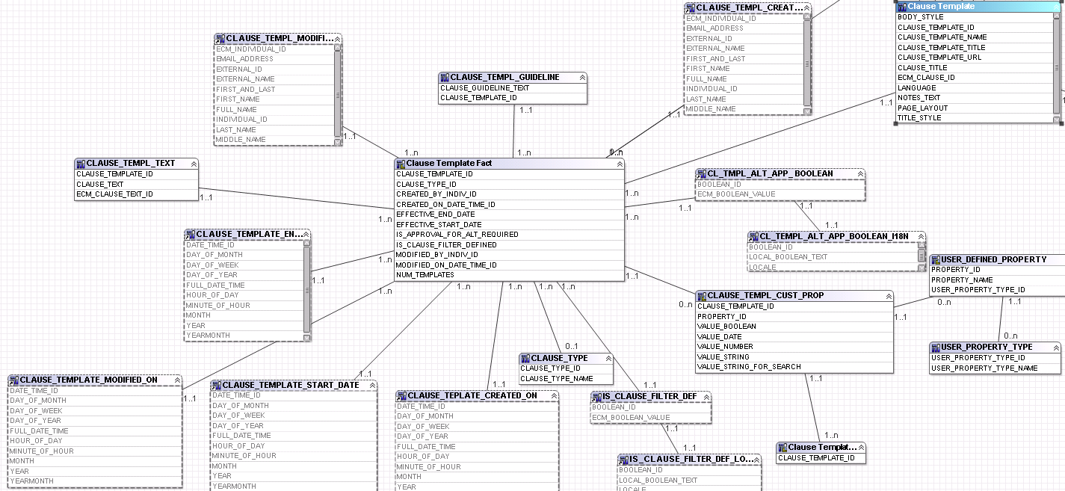
Figure 50 Clause Template Database layer
The clause template fact table contains information about the templates you have created. It tracks all the templates you have created in the IBM® Emptoris® Contract Management system.
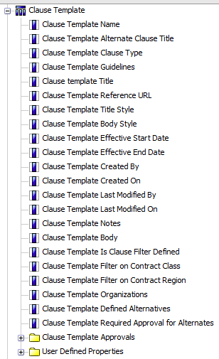
Dimensions are linked to the fact table via an inner join. Missing dimensional information is represented by a link to a record “0” to prevent data from being dropped by the model.
Figure 51 Clause Template
In the Cognos presentation (reporting) layer it is set up very similar to the clause query subject contracts. The first set of items is all at the contract clause level and result in one row of data per contract clause template.
These items correspond to the items that are in the contract clause record when it is created from this template. So just like a contract clause, a contract clause template has one Name, Alternative Clause title, type, etc…
These data items are followed by 2 folders. The folders represent data that is in a ‘one to many’ relationship with the contract template. Adding data items from these folders will return multiple rows of data per contract template. So just like a contract clause a contract clause template can have multiple default folders, default terms, default approvals, etc… Each of the folders contains multiple data items associated with this subject area.

Individuals

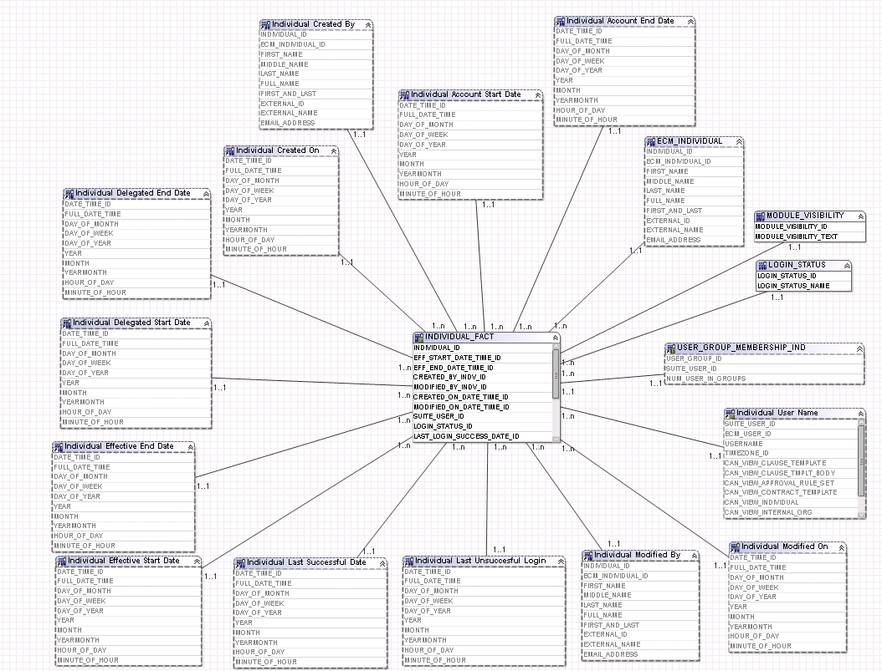
Figure 52 Individuals database layer
The INDIVIDUAL_FACT table looks at people who have any role on a contract. All individuals entered into the contract management system are listed in this table.
Dimensions are linked to the fact table via an inner join. Missing dimensional information is represented by a link to a record “0” to prevent data from being dropped by the model.

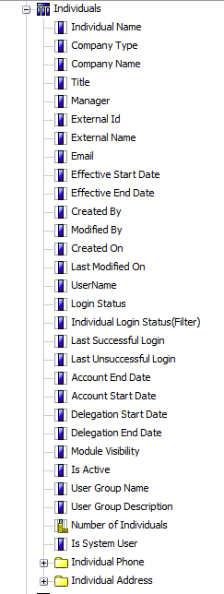
In the Cognos presentation (reporting) layer it the first set of items are all at the individual level and result in one row of data per contract clause template.
Figure 53 Individuals
These items represent detailed information that was entered about an individual. Not all fields are filled for every individual but any “un-entered” data is represented by a 0 record for “missing”. These items are all in a one to many relationships with the individual. An individual can only have one Name, Company type, Company name, Title, etc associated with them.
These data items are followed by 2 folders (Phone, Address). The folders represent data that is in a ‘one to many’ relationship with the individual. Adding data items from these folders will return multiple rows of data per individual. Each of the folders contains multiple data items associated with this subject area.

External Company

My Company Organization
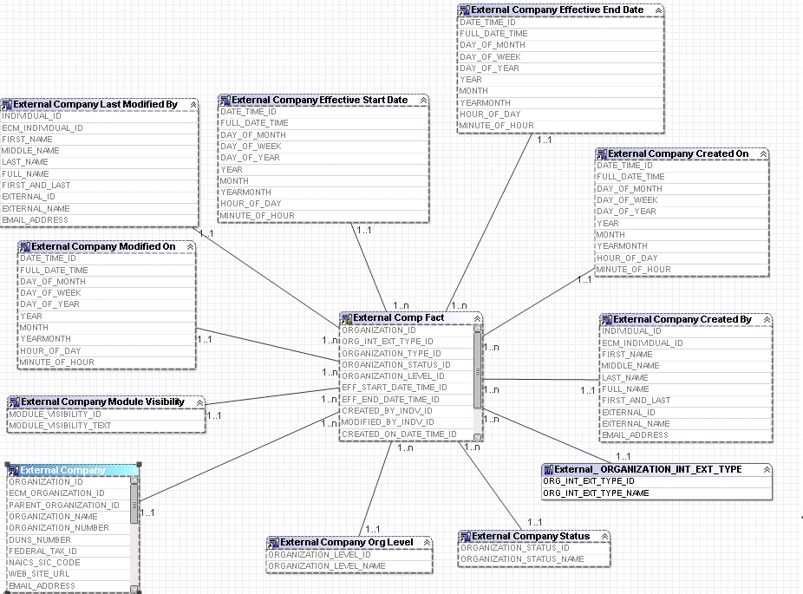
Figure 54 External Company database layer

These fact groupings are alias of Organization fact. In the database layer we only maintain one set of tables for organizations. For reporting, the organization tables are logically separated into Internal and External organizational entities. External organizations are presented via the External Company Folders and internal organizations are represented in the “My Company Organization” folder. The database field ORG_INT_EXT_TYPE_ID is used to differentiate between internal and external organizations.
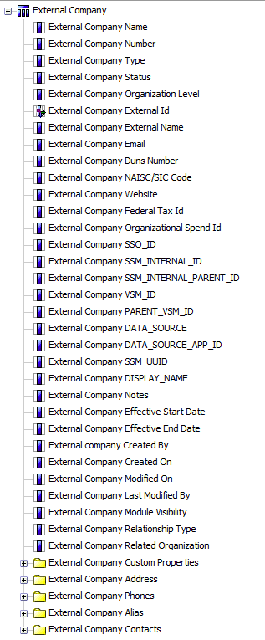
Figure 55 External Company
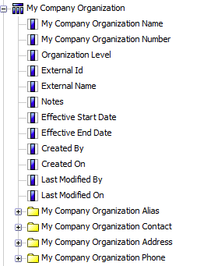
Figure 56 My Company

Approval Rule Set
The approval rule set tables are not connected to any other tables they sit independent in the model. They are not intended to be linked to any other tables. These tables store the information used to set up the interview questions and approval rules.
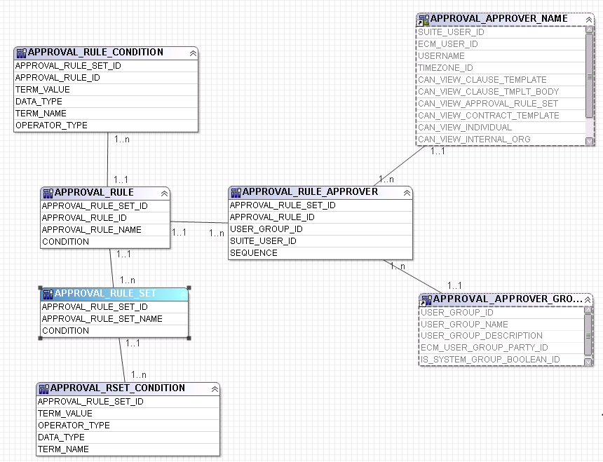
Figure 57 Approval Rule Set Database layer
Presentation layer
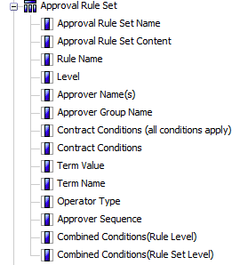
Figure 58 Approval Rule Set

Products
Products are linked to Line definitions.
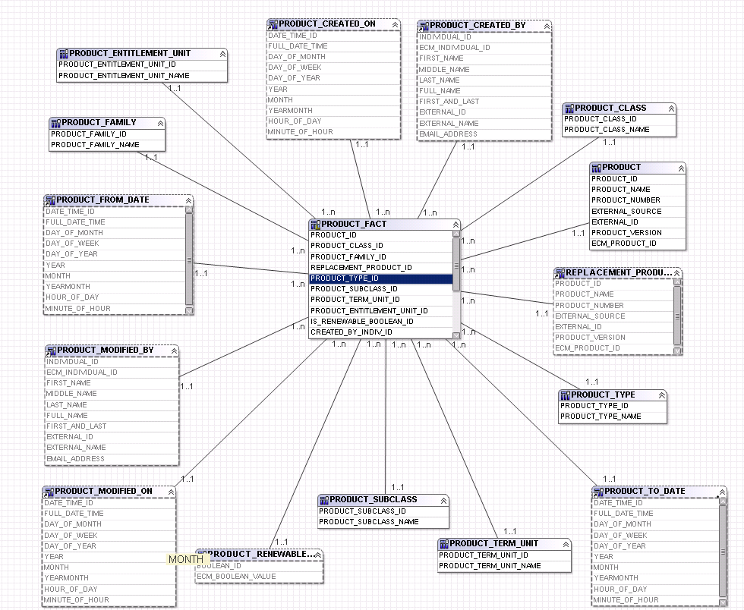
Figure 59 Products Database Layer

Products presentation layer
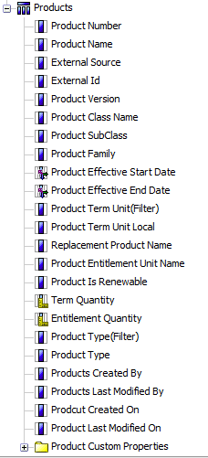
Figure 60 Products

Additional fact tables included in the basic Contracts model
These 20 facts are represented to report developers by folders at the same level as the ‘Contract’ folder. This data represents items that are in a ‘one to many’ relationship with a contract. For each contract, there are multiple rows in the fact table. These table groupings link to contract_fact via the contract dimension.
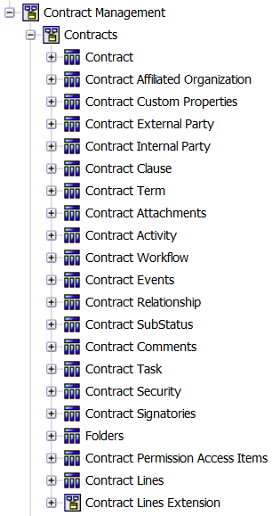
Figure 61 < Insert caption text here>

Affiliated Orgs - Alias of Contract_organization_fact

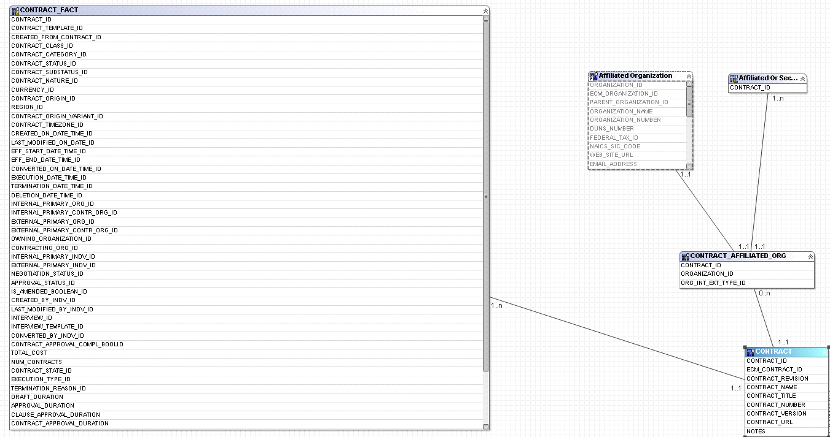
Figure 62 Affiliated Organization Database layer
Presentation Layer
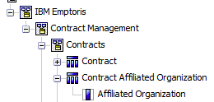
Figure 63 Affiliated Organization

Custom Properties
The custom properties fact table represents custom properties as one row of data per custom property attribute.

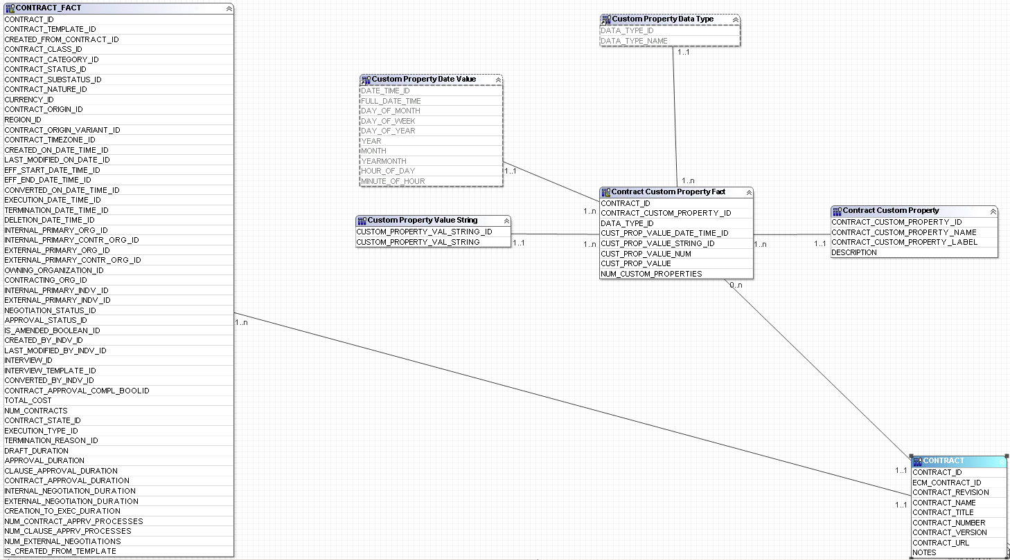
Figure 64 Custom Properties Database layer
Presentation layer
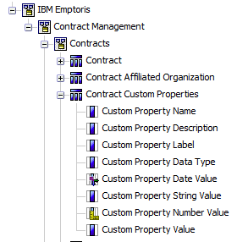
Figure 65 Custom properties

Contract External Party

Contract Internal Party

Contract External Party and Contract Internal Party are both an alias of the Organization fact table filtered for External / Internal organizations. The filter is applied using the ORG_INT_EXT_TYPE_ID field.
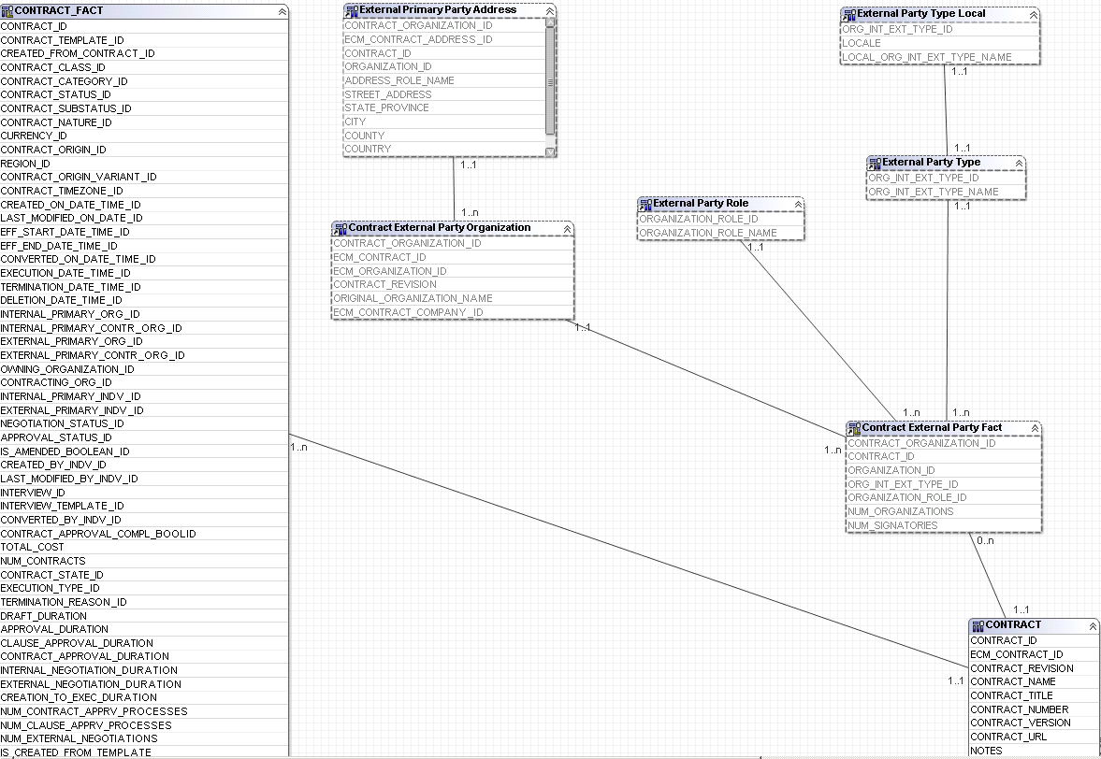
Figure 66 Organization fact database layer
Presentation layer
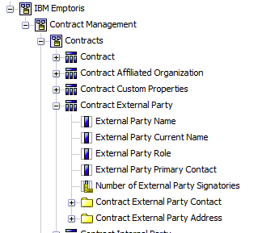
Figure 67 External party

Contract Clause
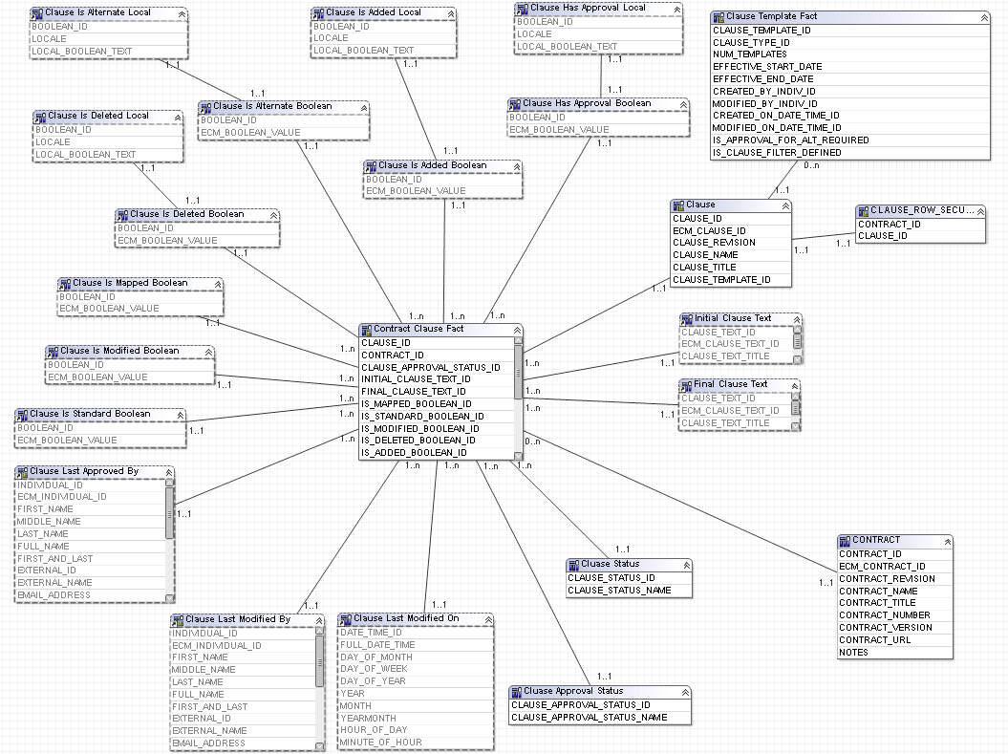

Presentation layer
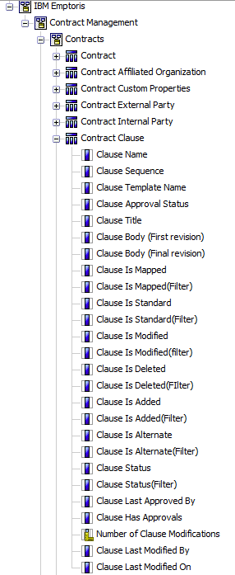
Figure 68 Contract Clause

Contract Term
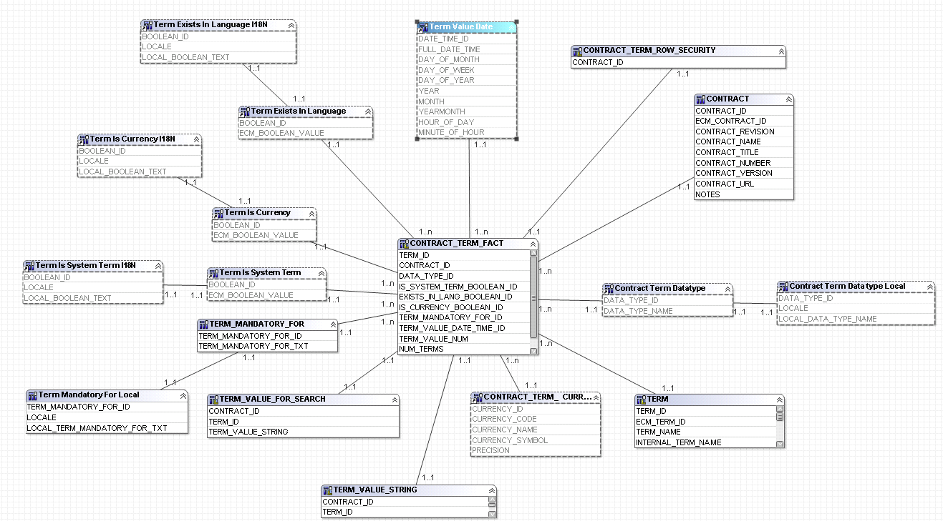
Figure 69 Contract term database layer
Presentation layer
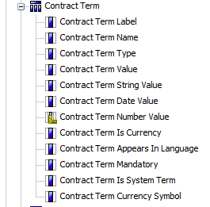
Figure 70 Contract term

Contract Attachments

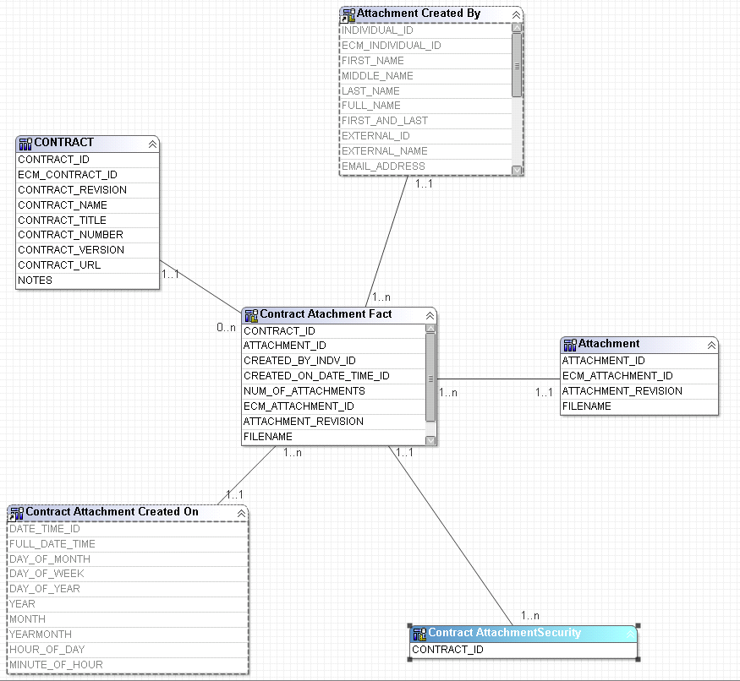
Figure 71 Contract Attachment database layer

Presentation Layer
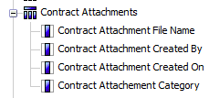
Figure 72 Contract attachment

Contract Activity

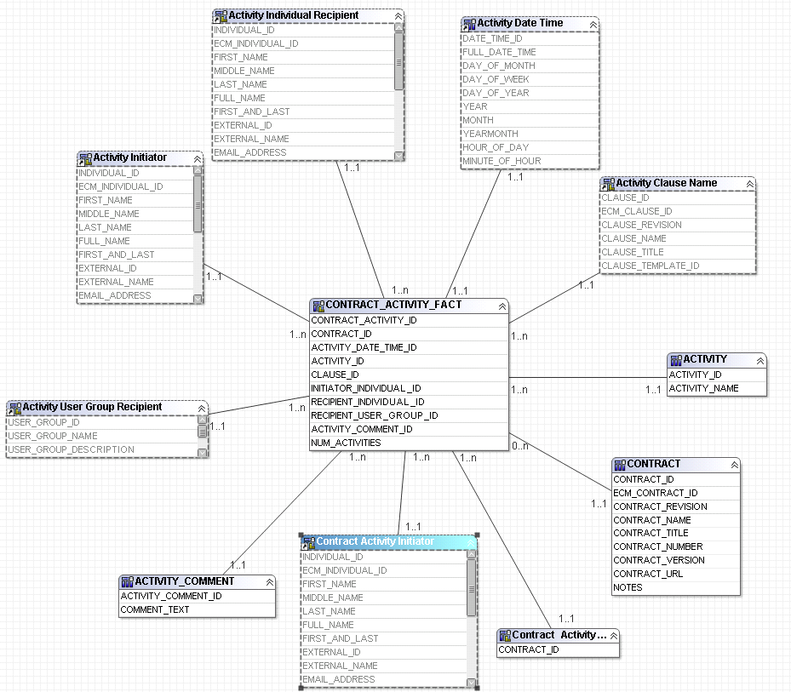
Figure 73 Contract Activity database layer

Presentation Layer
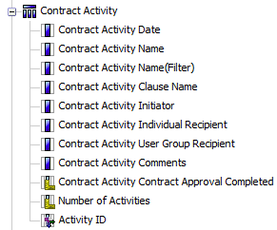
Figure 74 Contract Activity

Contract Workflow
This folder contains the workflow activity tracking items from contract fact. These items are calculated.
Contract workflow items are calculated based on activity records created during the creation and processing of a contract.
Note: Contracts that are bulk loaded with not have valid calculations for these items due to the fact that processing took place outside of the IBM® Emptoris® Contract Management system.
- DRAFT_DURATION(calculated)
- APPROVAL_DURATION (calculated)
- CLAUSE_APPROVAL_DURATION (calculated)
- CONTRACT_APPROVAL_DURATION (calculated)
- INTERNAL_NEGOTIATION_DURATION (calculated)
- EXTERNAL_NEGOTIATION_DURATION (Calculated)
- CREATION_TO_EXEC_DURATION (Calculated)
- NUM_CONTRACT_APPRV_PROCESSES (Calculated)
- NUM_CLAUSE_APPRV_PROCESSES (Calculated)
- NUM_EXTERNAL_NEGOTIATIONS (Calculated)

Presentation layer
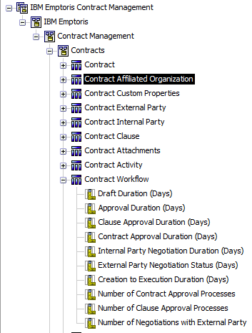
Figure 75 Contract workflow

Contract Events
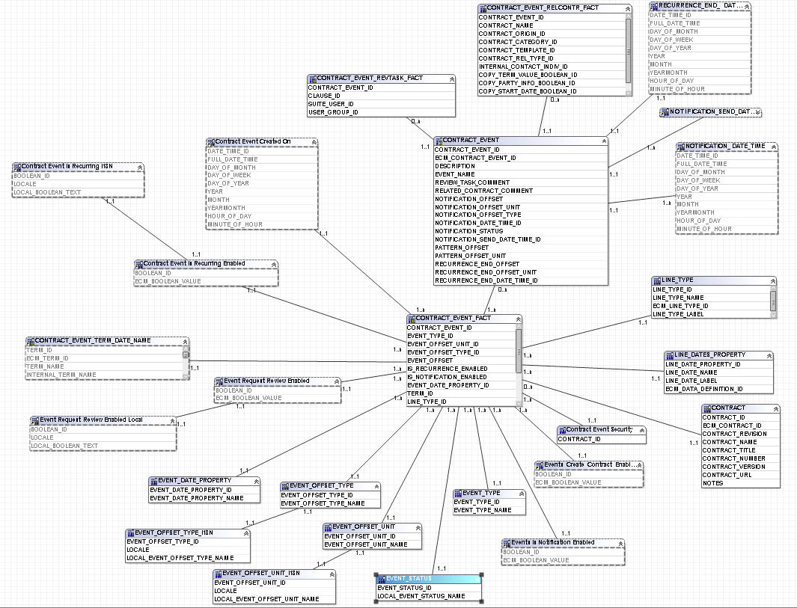
Figure 76 Contract Events database layer

Contract Events Presentation Layer
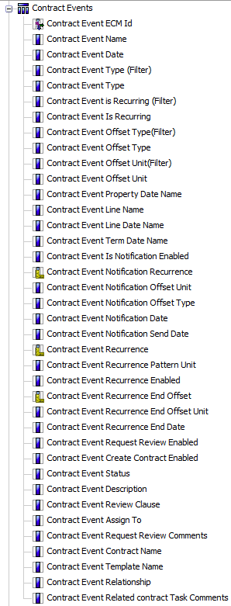
Figure 77 Contract events

Contract Relationship

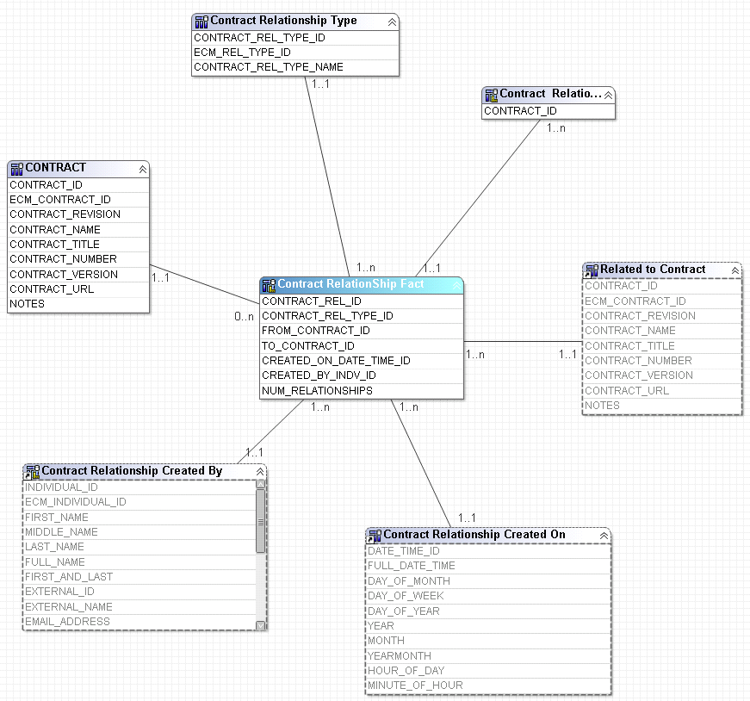
Figure 78 Contract Relationship database layer
Presentation Layer
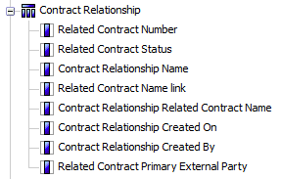
Figure 79 Contract relationship

Contract Substatus

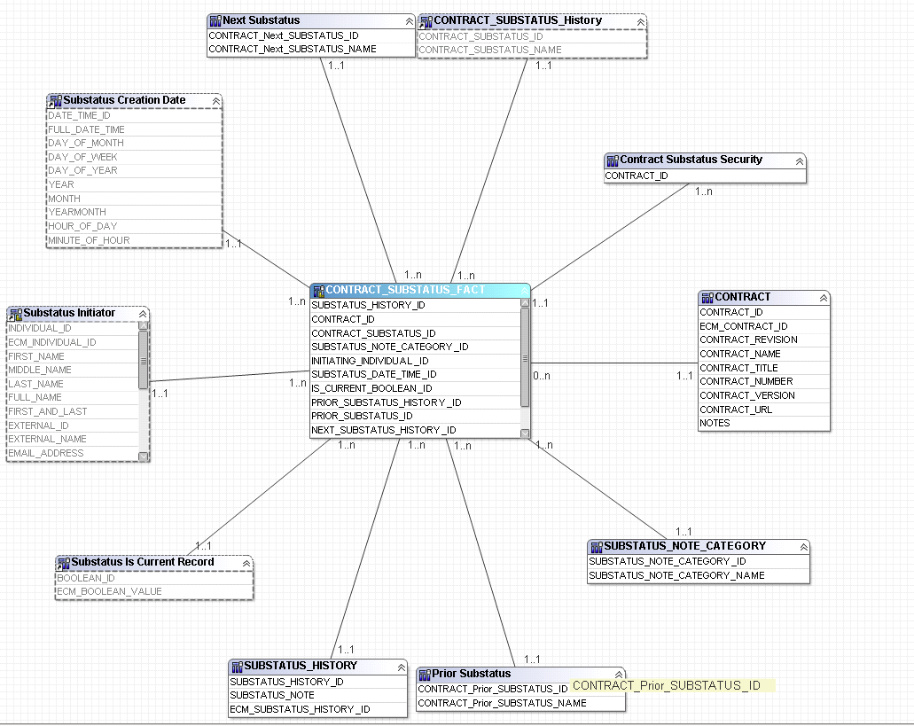
Figure 80 Contract sub-status database layer
Presentation Layer
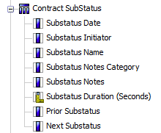
Figure 81 Contract substatus

Contract Comments

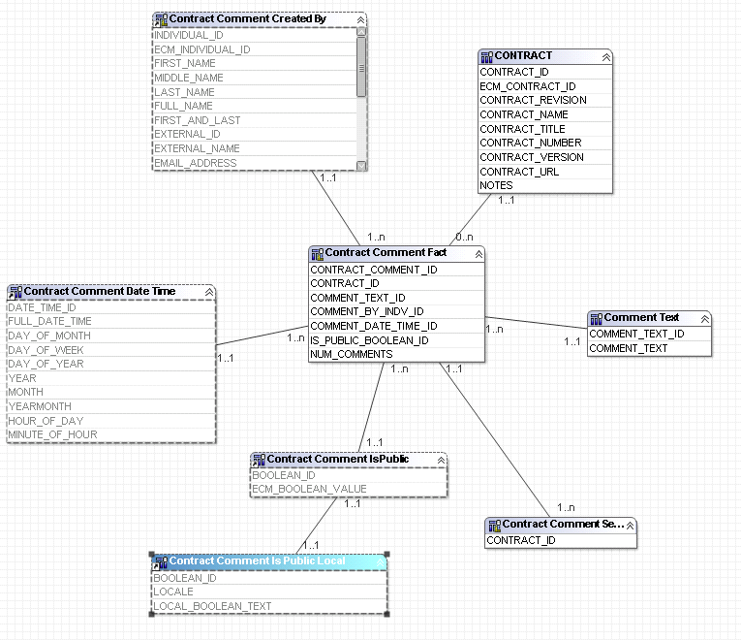
Figure 82 Contract Comments database layer
Presentation Layer
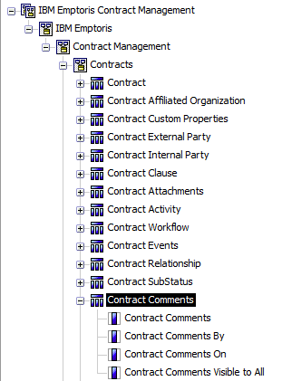
Figure 83 Contract Comments

Contact Task

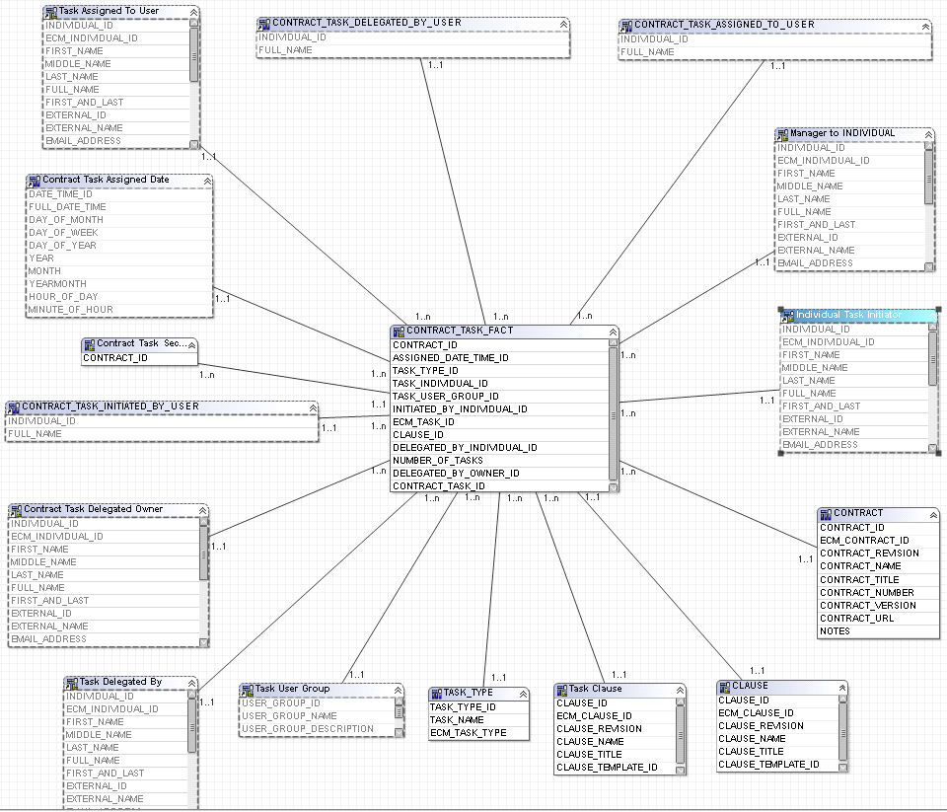
Figure 84 Contract task database layer

Presentation Layer
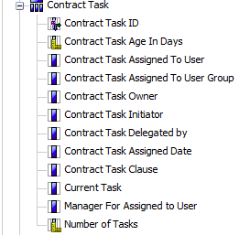
Figure 85 Contract task

Contract Security
The contract security tables are used for reporting on the security within contract management.

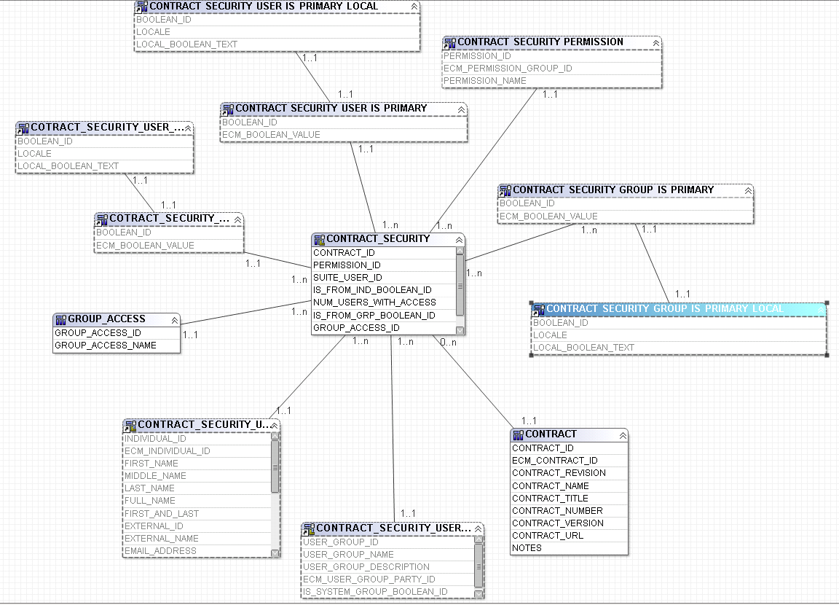
Figure 86 Contract security database layer
Presentation Layer
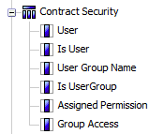
Figure 87 Contract security

Contract Signatories

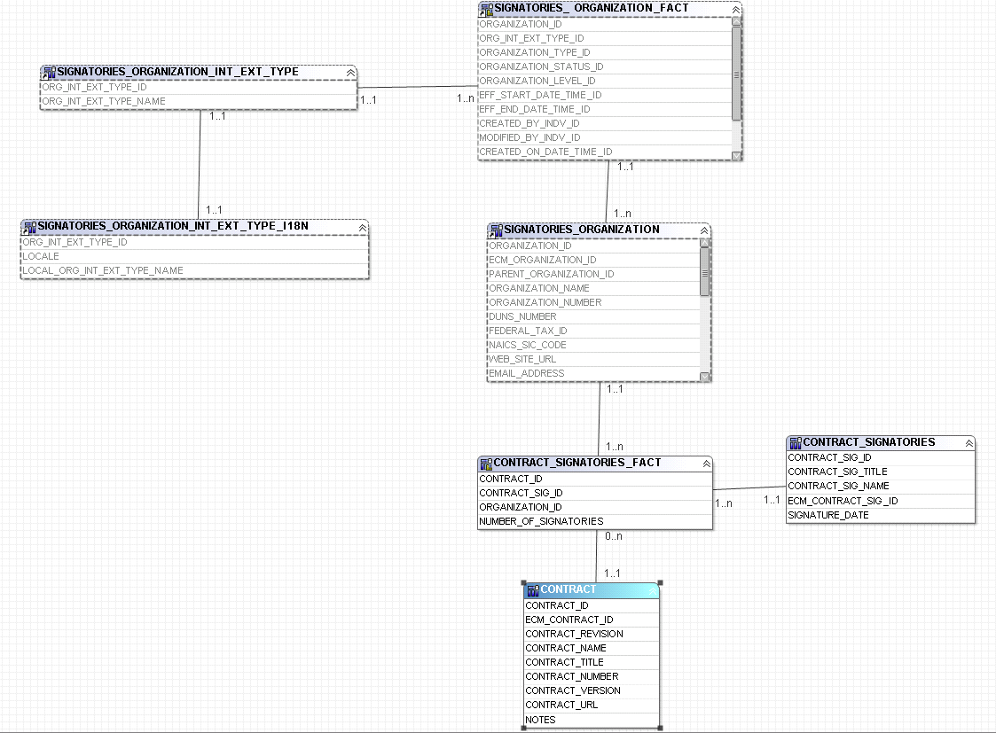
Figure 88 Contract Signatories database layer
Presentation Layer
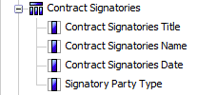
Figure 89 Contract Signatories

Folders

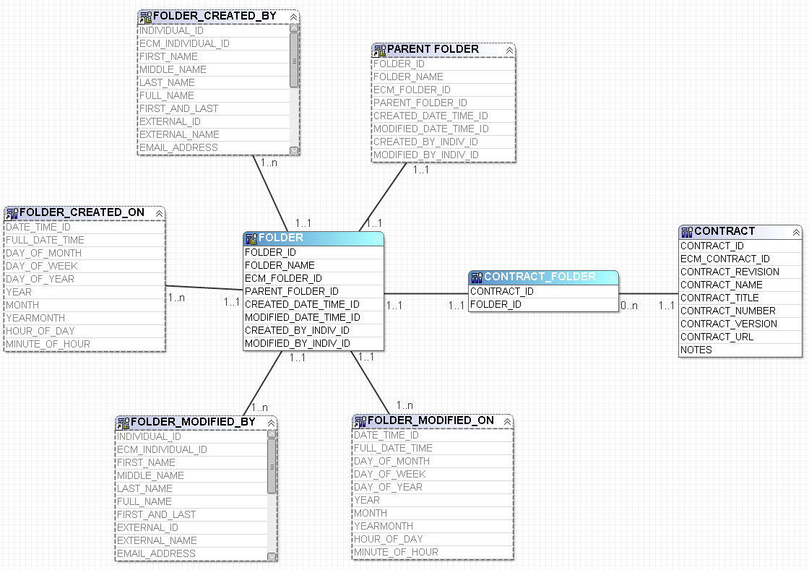
Figure 90 Contract Folders database layer
Presentation layer
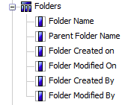
Figure 91 Contract folders

Contract Lines

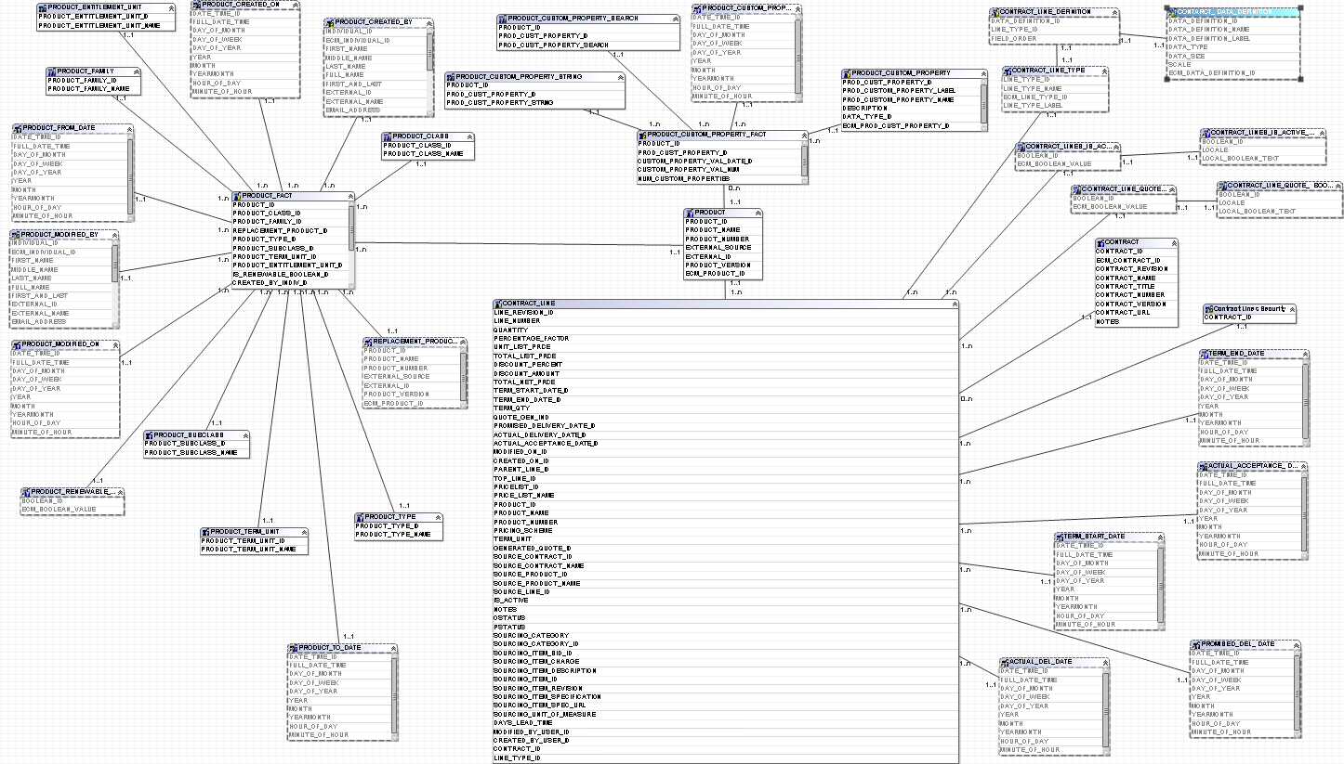
Figure 92 Contract Lines database layer
Presentation layer
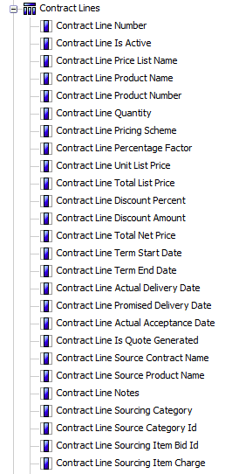
Figure 93 Contract Lines
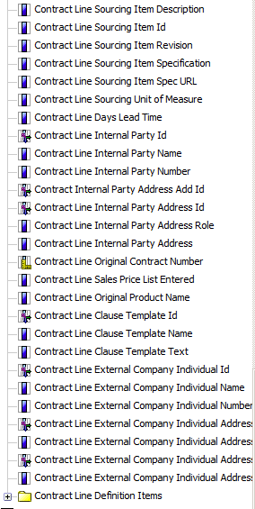
Figure 94 Contract lines (continued)

Contract Lines Ext
The content of this folder is adjusted based on the line items you have created.

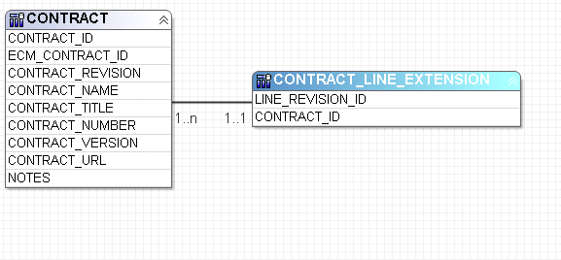
Figure 95 Contract Line extension database layer
Presentation layer
Dynamic

Appendices

Appendix A: Term reporting extension table

Starting in version 10.0.2.2 you are able to mark terms as available for reporting. Marking a term “Available for reporting” add this term as a column to a custom table. This table is represented in the presentation layer as “Contract Custom Terms” This table is generated dynamically by the ETL process. You can have up to 300 terms marked for reporting.
These term definitions stored as columns are located in the “Contract Custom Terms” folder under the “Contracts” folder.
Note: Terms are moved to the reporting database by the ETL jobs. The ETL must run before the terms will be visible in reporting. The term values are not visible in reporting until they are assigned to a contract.

Appendix B: Term Reporting
For version previous to 10.0.2.2 and for terms not mark “available for reporting”, We have created a sample term report for assisting developers with this type of reporting. The first thing to understand is that terms in the Contract Terms folder are stored as rows of data.

Sample Terms Report with Term Filtering

About
Sample terms report with term filtering is a sample report wherein you can add terms as columns and then use those columns in your filters. The report shows how to create three sample terms one Date Type term, One Character type term, and one Numeric Type Term and have a filter.

Procedure
To find a list of all terms those are not system terms:
(System terms are already included in the model and can be used without creating a custom term value)
- Open report studio and create a list report.
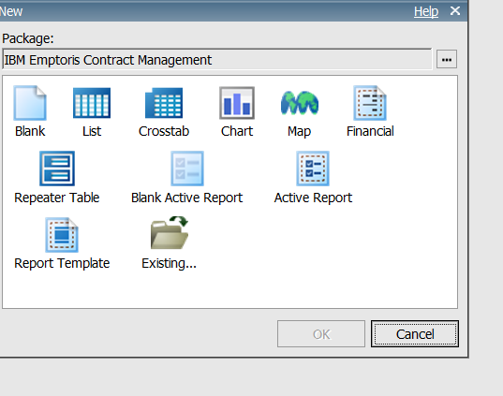
Figure 96 Report studio report types
- Add 4 data items to your report (Contract Term Label, Contract Term Name, Contract Term Type, Contract Term Is System Term)
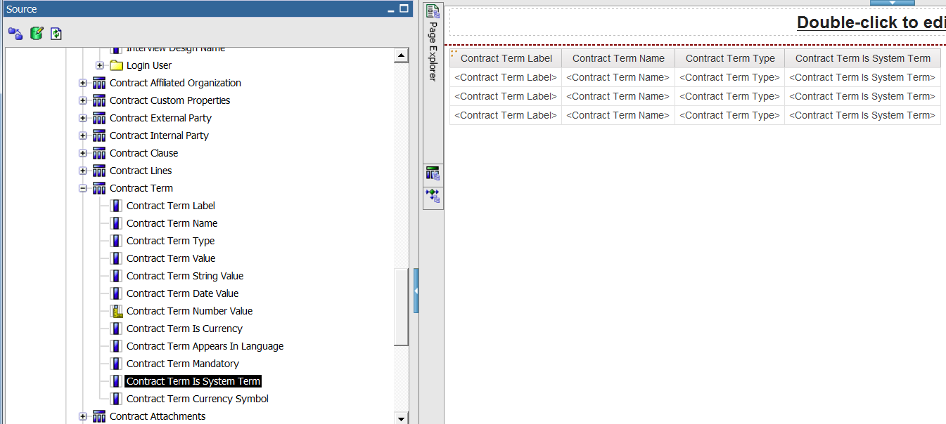
Figure 97 Terms as rows: Selecting term type

- Add a custom filter for Contract Term is System Term = ‘No’
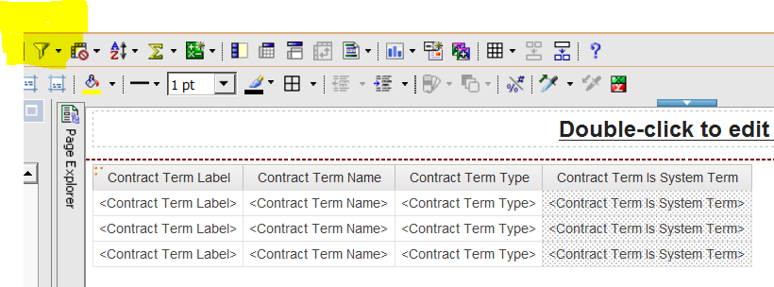
Figure 98 Filter Button
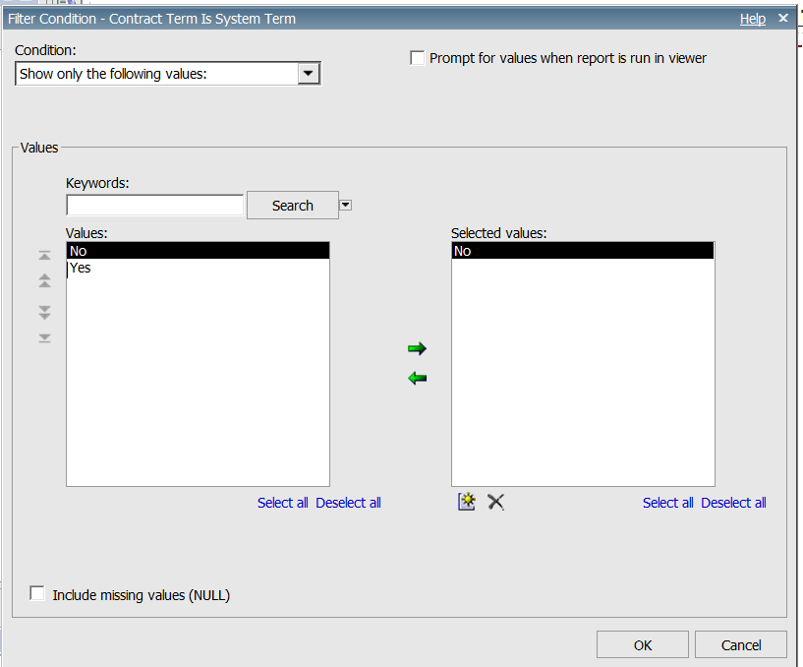
Figure 99 Filter dialog box
- This will give you a list of all the customer custom terms.
- Run this report as PDF and print the report.
- Verify that all custom terms have been created.
- Save the report in your ‘My Folders’ and then close the report
- Open the Sample term report.
- For each item on the report you created above add a new item to the query in the sample term report following the directions below.

To create addition terms as columns, complete the following steps:

- Copy the data item that represents the type of data item you wish to add. For our example we will use the term ‘Contract Title’ and replace it with the term ‘Contract Name’.
- Rename the item to the name of the term. (The new data item with have the same name as the old data item with a ‘1’ after it) For our example change the name from ‘Contract Title1’ to ‘Contract Name’.
- Open the equation for the data item and replace the term name in the first line of the equation with the term name you would like to use as a column. For example you could replace the ‘Contract Title’ term with ‘Contract Name’
  - Replace If([Contracts].[Contract Term].[Contract Term Name]='Contract Title')
  - With If([Contracts].[Contract Term].[Contract Term Name]='Contract Name')
- Make sure that the Data Item property ‘Aggregate Function’ is set to Maximum
  - 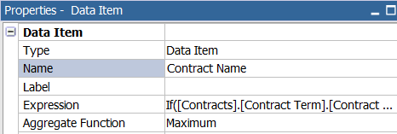
Figure 100 Data Item properties
- Add the data item to your report as a column.
- You can now use this data item in a filter value using the “Application” filter property of ‘After Auto Aggregation.
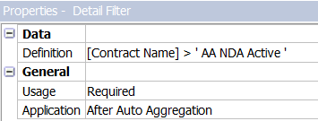
Figure 101 Data Item properties (Continued)

- Once you have added all the custom terms check to make sure that you have a new query item for every custom term.
- Save the new Sample term report with a new name ‘ Term report Template (existing terms already added)’

Appendix C: Custom lines
A major change in the 10.0.2 release was the inclusion of Contract Management user defined custom line items.

Principal design challenge:
- Dynamic nature of user defined fields;
- IBM® Emptoris® Contract Management data stored as rows, but used in reporting in column-oriented fashion;
- Large number of possible extension fields (hundreds);

What changed…
- Report Developers can create reports that contain IBM® EMPTORIS® CONTRACT MANAGEMENT user defined contract lines.
- Report Developers have contract lines reporting on ALL line fields.
- Reporting Model now can dynamically change as the IBM® EMPTORIS® CONTRACT MANAGEMENT user adds/removes custom fields.

Using our ETL tool DataStage, we allow the propagation of IBM® EMPTORIS® CONTRACT MANAGEMENT user-defined contract line extension fields from IBM® EMPTORIS® CONTRACT MANAGEMENT Source to the IBM® EMPTORIS® CONTRACT MANAGEMENT Reporting database.
This was accomplished leveraging the Java Integration stage and Cognos SDK, we implemented a mechanism to extend the Cognos model, making available customer-defined contract line extension fields in the Cognos BI reporting system.

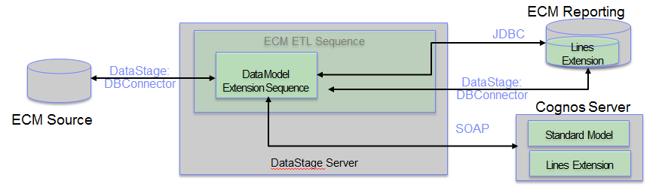
Figure 102 Custom Lines ETL operation diagram
What this means to you the advanced report developer is each time the ETL runs all new fields are available in the Lines Extension folder.

Converting date fields in Contract Lines to user time zones
We have documented detailed steps on how to achieve this. Here is a snapshot: Create the new data item using the date field and time zone function. Create a new Data Item by going to Toolbox red icon. Functions are located in the fourth tab. Drag the function to the editor. Then provide the macro.
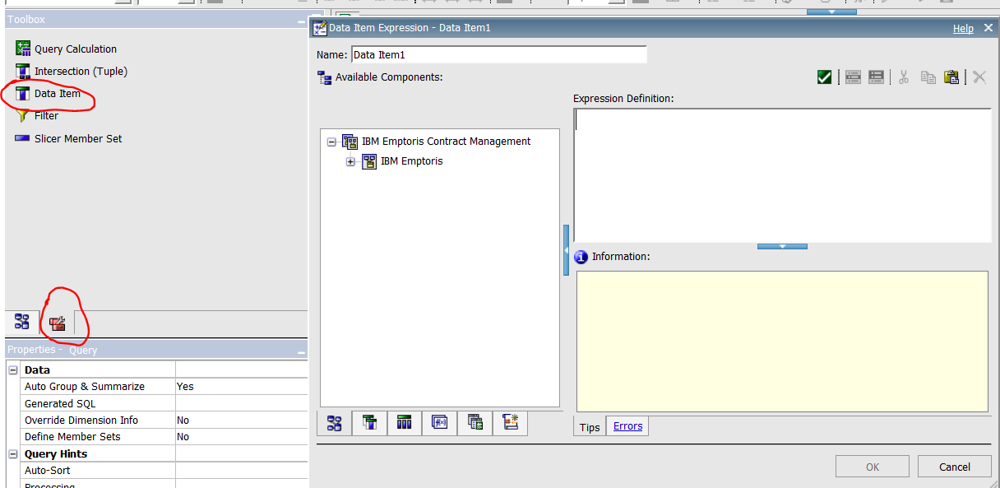
Figure 103 Building new Time item (Step1)
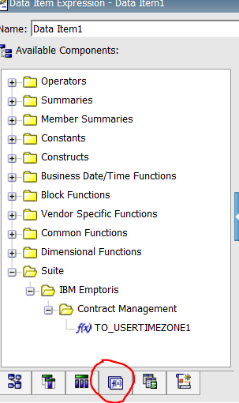
Figure 104 Building new time item (Step 2)

Appendix D: Indexed Fields
In order to support the dimensional model all ID fields are indexed to increase performance of the model. In addition, the following is a list of all non-ID fields that are indexed. These are especially good candidates for filters.

TABLE_NAME | COLUMN_NAME | LIST_OF_INDEXES
BOOLEAN | ECM_BOOLEAN_VALUE | IX_BOOLEAN__BOOLEAN_VALUE
BOOLEAN_I18N | LOCALE | BOOLEAN_I18N_PK
CLAUSE_APPROVAL_STATUS_I18N | LOCALE | CLAUSE_APPR_STATUS_I18N_PK
CLAUSE_STATUS_I18N | LOCALE | CLAUSE_STATUS_I18N_PK
CLAUSE_TEMPLATE_FACT | EFFECTIVE_END_DATE | XIF6CLAUSE_TEMPLATE_FACT
CLAUSE_TEMPLATE_FACT | EFFECTIVE_START_DATE | XIF5CLAUSE_TEMPLATE_FACT
CLAUSE_TEMPLATE_FACT | IS_APPROVAL_FOR_ALT_REQUIRED | XIF11CLAUSE_TEMPLATE_FACT
CLAUSE_TEMPLATE_FACT | IS_CLAUSE_FILTER_DEFINED | XIF12CLAUSE_TEMPLATE_FACT
CLAUSE_TEMPL_APPROVER | INCLUDE_PARENT_ORG | XIF4CLAUSE_TEMPL_APPROVERS
CLAUSE_TEMPL_CUST_PROP | VALUE_BOOLEAN | XIF4CLAUSE_TEMPL_CUST_PROP
CLAUSE_TEMPL_ORG_RELATION | IS_DIRECT_ASSOCIATION | XIF3CLAUSE_TEMPL_ORG_RELATION,XPKCLAUSE_TEMPL_ORG_RELATION
CONTRACT | CONTRACT_NUMBER | IX_CONTRACT_1
CONTRACT | CONTRACT_REVISION | IX_CONTRACT_2
CONTRACT_ATTACHMENT_FACT | ATTACHMENT_REVISION | IX_CONTRACT_ATTACHMENT_FACT_2
CONTRACT_ATTACHMENT_FACT | CATEGORY | IX_CT_ATT_FACT_CATEGORY
CONTRACT_CATEGORY | CONTRACT_CATEGORY_NAME | CONTRACT_CAT_U_NAME
CONTRACT_CATEGORY_I18N | LOCALE | CONTRACT_CATEGORY_I18N_PK
CONTRACT_CATEGORY_I18N | LOCAL_CATEGORY_NAME
CONTRACT_CLASS | CONTRACT_CLASS_NAME | CONTRACT_CLASS_U_NAME
CONTRACT_EVENT | NOTIFICATION_OFFSET | IX_CONTRACT_EVENT_2
CONTRACT_EVENT | NOTIFICATION_OFFSET_TYPE | IX_CONTRACT_EVENT_3
CONTRACT_EVENT | NOTIFICATION_OFFSET_UNIT | IX_CONTRACT_EVENT_4
CONTRACT_EVENT | NOTIFICATION_STATUS | IX_CONTRACT_EVENT_6
CONTRACT_EVENT | PATTERN_OFFSET | IX_CONTRACT_EVENT_7
CONTRACT_EVENT | PATTERN_OFFSET_UNIT | IX_CONTRACT_EVENT_8
CONTRACT_EVENT | RECURRENCE_END_OFFSET | IX_CONTRACT_EVENT_10
CONTRACT_EVENT | RECURRENCE_END_OFFSET_UNIT | IX_CONTRACT_EVENT_11
CONTRACT_EVENT_FACT | IS_CREATE_CONTRACT_ENABLED | IX_F15CONTRACT_EVENT_FACT2
CONTRACT_EVENT_FACT | IS_NOTIFICATION_ENABLED | IX_F8CONTRACT_EVENT_FACT2
CONTRACT_EVENT_FACT | IS_RECURRENCE_ENABLED | IX_F7CONTRACT_EVENT_FACT2
CONTRACT_EVENT_FACT | IS_REQUEST_REVIEW_ENABLED | IX_F14CONTRACT_EVENT_FACT2
CONTRACT_FACT | IS_AMENDED_BOOLEAN_ID | IX_CONF_ISAMENDBOOLID
CONTRACT_FACT | IS_CREATED_FROM_TEMPLATE | IX_CONTRACT_FACT_2
CONTRACT_LINE | IS_ACTIVE | IX_CONTRACT_LINE_6
CONTRACT_LINE | LINE_NUMBER | IX_CONTRACT_LINE_7
CONTRACT_LINE | PRODUCT_NAME | IX_CONTRACT_LINE_13
CONTRACT_NATURE | CONTRACT_NATURE_NAME | IX_CONTRACT_NATURE_1
CONTRACT_ORGANIZATION | CONTRACT_REVISION | IX_CONTRACT_ORGANIZATION_1
CONTRACT_ORGANIZATION_ADDRESS | COUNTRY | IX_CONTRACT_ORG_ADDRESS_2
CONTRACT_ORGANIZATION_ADDRESS | COUNTY | IX_CONTRACT_ORG_ADDRESS_3
CONTRACT_ORGANIZATION_ADDRESS | POSTAL_CODE | IX_CONTRACT_ORG_ADDRESS_4
CONTRACT_ORGANIZATION_ADDRESS | STATE_PROVINCE | IX_CONTRACT_ORG_ADDRESS_5
CONTRACT_ORGANIZATION_RELATION | IS_DIRECT_ASSOCIATION | XPKCONTRACT_ORGANIZATION_RELAT
CONTRACT_ORIGIN_I18N | LOCALE | XPKCONTRACT_ORIGNIN_I18N
CONTRACT_RELATIONSHIP_TYPE | CONTRACT_REL_TYPE_NAME | IX_CONTRACT_REL_TYPE_1
CONTRACT_SIGNATORIES | SIGNATURE_DATE | IX_CONTRACT_SIGNATORIES_1
CONTRACT_STATE | CONTRACT_STATE_NAME | IX_CONTRACT_STATE_1
CONTRACT_STATUS | CONTRACT_STATUS_NAME | CONTRACT_STATUS_U_NAME
CONTRACT_STATUS_I18N | LOCALE | CONTRACT_STATUS_I18N_PK
CONTRACT_STATUS_I18N | LOCAL_STATUS_NAME | IX_CONTRACT_STATUS_I18N_1
CONTRACT_SUBSTATUS | CONTRACT_SUBSTATUS_NAME | CONTRACT_SUBSTATUS_U_NAME
CONTRACT_TEMPLATE | CONTRACT_TEMPLATE_NAME | IX_CONTRACT_TEMPLATE_1
CONTRACT_TEMPLATE_APPROVAL | CONTRACT_ORGANIZATION_TYPE | IX_CONTRACT_TEMPL_APPROVAL_1
CONTRACT_TEMPLATE_APPROVAL | INCLUDE_PARENT_ORGANIZATION | XIF4CONTRACT_TEMPLATE_APPROVAL
CONTRACT_TEMPLATE_APP_I18N | LOCALE | XPKCONTRACT_TEMPLATE_APP_I18N
CONTRACT_TEMPLATE_APP_I18N | LOCAL_APPLICABILITY_NAME | IX_CONTRACT_TEMPL_APP_I18N_1
CONTRACT_TEMPLATE_EVENT | NOTIFICATION_OFFSET | IX_CONTRACT_TEMPLATE_EVENT_2
CONTRACT_TEMPLATE_EVENT | NOTIFICATION_OFFSET_TYPE | IX_CONTRACT_TEMPLATE_EVENT_3
CONTRACT_TEMPLATE_EVENT | NOTIFICATION_OFFSET_UNIT | IX_CONTRACT_TEMPLATE_EVENT_4
CONTRACT_TEMPLATE_EVENT | PATTERN_OFFSET | IX_CONTRACT_TEMPLATE_EVENT_5
CONTRACT_TEMPLATE_EVENT | PATTERN_OFFSET_UNIT | IX_CONTRACT_TEMPLATE_EVENT_6
CONTRACT_TEMPLATE_EVENT | RECURRENCE_END_OFFSET | IX_CONTRACT_TEMPLATE_EVENT_7
CONTRACT_TEMPLATE_EVENT | RECURRENCE_END_OFFSET_UNIT | IX_CONTRACT_TEMPLATE_EVENT_8
CONTRACT_TEMPLATE_EV_FACT | IS_CREATE_CONTRACT_ENABLED | XIF12CONTRACT_TEMPLATE_EV_FACT
CONTRACT_TEMPLATE_EV_FACT | IS_NOTIFICATION_ENABLED | XIF6CONTRACT_TEMPLATE_EV_FACT
CONTRACT_TEMPLATE_EV_FACT | IS_RECURRENCE_ENABLED | XIF5CONTRACT_TEMPLATE_EV_FACT
CONTRACT_TEMPLATE_EV_FACT | IS_REQUEST_REVIEW_ENABLED | XIF11CONTRACT_TEMPLATE_EV_FACT
CONTRACT_TEMPLATE_FACT | DEFAULT_NEGOTIABILITY | IX_CONTRACT_TEMPLATE_FACT_2
CONTRACT_TEMPLATE_LINE | IS_SOURCING_LINE | XIF3CONTRACT_TEMPLATE_LINES
CONTRACT_TEMPLATE_LINE | LINE_TYPE_ORDER | IX_CONTRACT_TEMPLATE_LINE_1
CONTRACT_TEMPLATE_STATUS_I18N | LOCALE | CONTRACT_TEMPL_STATUS_I18N_PK
CONTRACT_TERM_FACT | TERM_VALUE_NUM | IX_CONTRACT_TERM_FACT_2
CONTRACT_TMP_ORG_RELATION | IS_DIRECT_ASSOCIATION | XIF4CONTRACT_TMP_ORG_RELATION,XPKCONTRACT_TMP_ORG_RELATION
CURRENCY | CURRENCY_CODE | IX_CURRENCY_1
CURRENCY | CURRENCY_NAME | IX_CURRENCY_2
CURRENCY | CURRENCY_SYMBOL | IX_CURRENCY_3
DATA_DEFINITION | DATA_DEFINITION_LABEL | IX_DATA_DEFINITION_1
DATA_DEFINITION | DATA_DEFINITION_NAME | IX_DATA_DEFINITION_2
DATA_TYPE | DATA_TYPE_NAME | IX_DATA_TYPE_1
DATA_TYPE_I18N | LOCALE | PK_DATA_TYPE_I18N
DATA_TYPE_I18N | LOCAL_DATA_TYPE_NAME | IX_DATA_TYPE_I18N_1
DATE_TIME | FULL_DATE_TIME | IX_DATE_TIME_1
EVENT_DATE_PROPERTY | EVENT_DATE_PROPERTY_NAME | IX_EVENT_DATE_PROPERTY_1
EVENT_DATE_PROPERTY_I18N | LOCALE | PK_EVENT_DATE_PROPERTY_I18N
EVENT_DATE_PROPERTY_I18N | LOCAL_EVENT_DATE_PROPERTY | IX_EVENT_DATE_PROPERTY_I18N_1
EVENT_OFFSET_TYPE | EVENT_OFFSET_TYPE_NAME | IX_EVENT_OFFSET_TYPE_1
EVENT_OFFSET_TYPE_I18N | LOCALE | XPKEVENT_OFFSET_TYPE_I18N
EVENT_OFFSET_TYPE_I18N | LOCAL_EVENT_OFFSET_TYPE_NAME | IX_EVENT_OFFSET_TYPE_I18N_1
EVENT_OFFSET_UNIT | EVENT_OFFSET_UNIT_NAME | IX_EVENT_OFFSET_UNIT_1
EVENT_OFFSET_UNIT_I18N | LOCALE | XPKEVENT_OFFSET_UNIT_I18N
EVENT_OFFSET_UNIT_I18N | LOCAL_EVENT_OFFSET_UNIT_NAME | IX_EVENT_OFFSET_UNIT_I18N_1
EVENT_STATUS | LOCAL_EVENT_STATUS_NAME | IX_EVENT_STATUS_1
EVENT_STATUS_I18N | LOCALE | PK_EVENT_STATUS_I18N
EVENT_STATUS_I18N | LOCAL_EVENT_STATUS_NAME | IX_EVENT_STATUS_I18N_1
EVENT_TYPE | EVENT_TYPE_NAME | IX_EVENT_TYPE_1
EVENT_TYPE_I18N | LOCALE | EVENT_TYPE_I18N_PK
EVENT_TYPE_I18N | LOCAL_EVENT_TYPE_NAME | IX_EVENT_TYPE_I18N_1
EXECUTION_TYPE | EXECUTION_TYPE_NAME | IX_EXECUTION_TYPE_1
FOLDER | FOLDER_NAME | IX_FOLDER_2
GROUP_ACCESS | GROUP_ACCESS_NAME | IX_GROUP_ACCESS_1
INDIVIDUAL_ADDRESS | ADDRESS_ROLE_NAME | IX_INDIVIDUAL_ADDRESS_1
INDIVIDUAL_ADDRESS | CITY | IX_INDIVIDUAL_ADDRESS_2
INDIVIDUAL_ADDRESS | COUNTRY | IX_INDIVIDUAL_ADDRESS_3
INDIVIDUAL_ADDRESS | COUNTY | IX_INDIVIDUAL_ADDRESS_4
INDIVIDUAL_ADDRESS | POSTAL_CODE | IX_INDIVIDUAL_ADDRESS_6
INDIVIDUAL_FACT | IS_SYSTEM | XIF17INDIVIDUAL_FACT
INDIVIDUAL_PHONE | PHONE_TYPE_NAME | IX_INDIVIDUAL_PHONE_1
INTERVIEW | INTERVIEW_NAME | IX_INTERVIEW_1
INTERVIEW_TEMPLATE | INTERVIEW_TEMPLATE_NAME | IX_INTERVIEW_TEMPLATE_1
LINE_DATES_PROPERTY | LINE_DATE_LABEL | IX_LINE_DATES_PROPERTY_1
LINE_DATES_PROPERTY | LINE_DATE_NAME | IX_LINE_DATES_PROPERTY_2
LINE_TYPE | LINE_TYPE_LABEL | IX_LINE_TYPE_1
LINE_TYPE | LINE_TYPE_NAME | IX_LINE_TYPE_2
LOGIN_STATUS | LOGIN_STATUS_NAME | IX_LOGIN_STATUS_1
LOGIN_STATUS_I18N | LOCALE | LOGIN_STATUS_I18N_PK
LOGIN_STATUS_I18N | LOCAL_LOGIN_STATUS_NAME | IX_LOGIN_STATUS_I18N_1
MODULE_VISIBILITY | MODULE_VISIBILITY_TEXT | IX_MODULE_VISIBILITY_1
NEGOTIATION_STATUS | NEGOTIATION_STATUS_TEXT | IX_NEGOTIATION_STATUS_1
ORGANIZATION | DATA_SOURCE | IX_ORGANIZATION_1
ORGANIZATION | DUNS_NUMBER | IX_ORGANIZATION_3
ORGANIZATION | EXTERNAL_SYSTEM_NAME | IX_ORGANIZATION_5
ORGANIZATION | FEDERAL_TAX_ID | IX_ORGANIZATION_6
ORGANIZATION | NAICS_SIC_CODE | IX_ORGANIZATION_7
ORGANIZATION | ORGANIZATION_NAME | IX_ORGANIZATION_8
ORGANIZATION | ORGANIZATION_NUMBER | IX_ORGANIZATION_9
ORGANIZATION_ADDRESS | STATE_PROVINCE | IX_ORGANIZATION_ADDRESS_5
ORGANIZATION_ALIAS | ECM_ORGANIZATION_ALIAS | ECM_ORG_ALIAS_ID_IX
ORGANIZATION_CUSTOM_PROPERTY | ORG_CUSTOM_PROPERTY_LABEL | IX_ORGANIZATION_CUSTOM_P2
ORGANIZATION_INT_EXT_TYPE | ORG_INT_EXT_TYPE_NAME | IX_ORGANIZATION_INT_ET_1
ORGANIZATION_INT_EXT_TYPE_I18N | LOCALE | ORG_INT_EXT_TYPE_I18N_PK
ORGANIZATION_INT_EXT_TYPE_I18N | LOCAL_ORG_INT_EXT_TYPE_NAME | IX_ORGANIZATION_INT_ET_I18N_1
ORGANIZATION_RELATIONSHIP_TYPE | ORGANIZATION_REL_TYPE_NAME | IX_ORGANIZATION_RELT_1
ORGANIZATION_ROLE | ORGANIZATION_ROLE_NAME | IX_ORGANIZATION_ROLE_1
ORGANIZATION_STATUS | ORGANIZATION_STATUS_NAME | IX_ORGANIZATION_STATUS_1
PRODUCT | EXTERNAL_SOURCE | PROD_EXTERNAL
PRODUCT | PRODUCT_NAME | IX_PRODUCT_1
PRODUCT | PRODUCT_NUMBER | PROD_PROD_NUMBER_IX
PRODUCT_TYPE_I18N | LOCALE | XPKPRODUCT_TYPE_I18N
SUITE_USER | USERNAME | IX_SUITEUSER_USERNAME
TASK_TYPE | ECM_TASK_TYPE | IX_TASK_TYPE__TASK_TYPE
TASK_TYPE_I18N | LOCALE | PK_TASK_TYPE_I18N
TERM | IS_MULTI_VALUE | XIF1TERM
TERM | IS_SYSTEM_TERM | IX_TERM_1
TERM | IS_USED_FOR_REPORTING | IX_TERM_2
TERM | TERM_NAME | IX_TERM_NAME
TERM | TYPE | IX_TERM_TYPE
TERMINATION_REASON | TERMINATION_REASON_CODE | IX_TERMINATION_REASON_1
TERM_MANDATORY_FOR | TERM_MANDATORY_FOR_TXT | IX_TERM_MANDATORY_FOR_1
TERM_MANDATORY_FOR_I18N | LOCALE | PK_TERM_MANDATORY_FOR_I18N
TERM_MANDATORY_FOR_I18N | LOCAL_TERM_MANDATORY_FOR_TXT | IX_TERM_MANDATORY_FOR_I18N_1
TIMEZONE | TIMEZONE_NAME | IX_TIMEZONE_1
USER_DEFINED_PROPERTY | PROPERTY_NAME | IX_USER_DEFINED_PROPERTY_1
USER_GROUP | USER_GROUP_NAME | IX_USER_GROUP_1
USER_PROPERTY_TYPE | USER_PROPERTY_TYPE_NAME | IX_USER_PROPERTY_TYPE_1
Figure 105 Indexed items

Appendix E: Large text fields

A number of fields in the IBM® EMPTORIS® CONTRACT MANAGEMENT database contain very large amounts of text. Any field that contained more than 1000 characters of data was truncated to 1000 characters. The following is a list of large text fields that have been truncated.
TABLE_NAME | COLUMN_NAME | # Characters
ACTIVITY_COMMENT | COMMENT_TEXT | 1000
ATTACHMENT | FILENAME | 750
CLAUSE | CLAUSE_NAME | 750
CLAUSE | CLAUSE_TITLE | 750
CLAUSE_TEXT | CLAUSE_TEXT | 750
CLAUSE_TEXT | CLAUSE_TEXT_TITLE | 1000
COMMENT_TEXT | COMMENT_TEXT | 1000
CONTRACT | CONTRACT_TITLE | 1000
CONTRACT_ATTACHMENT_FACT | FILENAME | 750
CONTRACT_CATEGORY_I18N | LOCAL_CATEGORY_NAME | 1000
CONTRACT_CUSTOM_PROPERTY | DESCRIPTION | 750
CONTRACT_CUSTOM_PROPERTY_FACT | CUST_PROP_VALUE | 1000
CONTRACT_EVENT | RELATED_CONTRACT_COMMENT | 1000
CONTRACT_EVENT | REVIEW_TASK_COMMENT | 1000
CONTRACT_LINE | CLAUSE_TEMPLATE_NAME | 1000
CONTRACT_LINE | CLAUSE_TEMPLATE_TEXT | 1000
CONTRACT_LINE | EXTERNAL_COMP_IND_ADDR | 1000
CONTRACT_LINE | NOTES | 1000
CONTRACT_ORGANIZATION_ADDRESS | STREET_ADDRESS | 1000
CONTRACT_TEMPLATE_EVENT | RELATED_CONTRACT_COMMENT | 1000
CONTRACT_TEMPLATE_EVENT | REVIEW_TASK_COMMENT | 1000
CUSTOM_PROPERTY_VALUE_STRING | CUSTOM_PROPERTY_VAL_STRING | 1000
EXECUTION_TYPE | EXECUTION_TYPE_NAME | 1000
INDIVIDUAL_ADDRESS | STREET_ADDRESS | 1000
ORGANIZATION | NOTES | 1000
ORGANIZATION_CUSTOM_PROPERTY | DESCRIPTION | 750
ORGANIZATION_CUSTOM_PROP_FACT | CUSTOM_PROPERTY_VALUE | 1000
ORGANIZATION_CUST_PROP_STRING | ORG_CUSTOM_PROPERTY_VAL_STRING | 1000
PRODUCT_CUSTOM_PROPERTY | DESCRIPTION | 1000
PRODUCT_CUSTOM_PROPERTY_SEARCH | PROD_CUST_PROPERTY_SEARCH | 1000
PRODUCT_CUSTOM_PROPERTY_STRING | PROD_CUST_PROPERTY_STRING | 1000
RELATED_CONTRACT_COMMENT | RELATED_CONTRACT_COMMENT_TEXT | 1000
REQUEST_REVIEW_COMMENT | REQUEST_REVIEW_COMMENT_TEXT | 1000
SUBSTATUS_HISTORY | SUBSTATUS_NOTE | 1000
SUBSTATUS_NOTE_CATEGORY | SUBSTATUS_NOTE_CATEGORY_NAME | 1000
TERM_VALUE_STRING | TERM_VALUE_STRING | 1000
USER_GROUP | USER_GROUP_DESCRIPTION | 1000

Appendix F: Security

Access to reporting Security
In order to access the reporting application you must be a member of one of three VSM groups. Membership in these groups grants you access to the Reporting Portal. Access to individual contracts is controlled by row level security see below for more information. Thus it is possible to be granted access to create / run reports but not have access to any contracts. In this case reports will generate a report with no data.
- Report Writers
- Reporting Administrators
- Report Viewers
Each installation should only have one or two “Reporting Administrators” and these users will need additional training in administering the Cognos environment.
Note: Reporting Administrators have the ability to overwrite all default reporting portal settings.
Report Writers have the ability to run pre-existing reports, create dashboards, and create and save reports in their ‘My Folders’ and in other folders designated by a Reporting Administrator.
Currently Report Viewers is only used for the Spend application.
Note: The simplest way to test basic security is to create a simple list report with only contract name and number. If they don't see the contract in this report it is a contract read permissions issue.

Row Level Security
Security in Contract Management is very complex and in reporting we have attempted to bring that security model forward to reporting. Permissions can be assigned on both an individual and a Group. When permissions are assigned to a group all members of that group and members of any group that is assigned to that group gain the access granted.
A good rule of thumb is if you can see it in IBM® EMPTORIS® CONTRACT MANAGEMENT you should be able to see it in reporting. If you cannot see it in IBM® EMPTORIS® CONTRACT MANAGEMENT you should not be able to see it in reporting.
The following shows the IBM® EMPTORIS® CONTRACT MANAGEMENT permission(s) that you should have to see each section of data you may receive this permission directly or through inheritance from a group you are a member of. You access may still be limited by class level permissions. (See below for more information on class level security)

Permissions

To see a contract you must have Contract> Read or one of its subclasses permission assigned to you directly or to a group you are a member of. In addition the groups you belong to can inherit these permissions. In addition “Contract > Read” is granted to a user when they receive a Review or an Approval request and can be grated when you are assigned tasks via Delegation and Reassignment.
- Example one: I give you “Contract > Read” permission on a contract directly.
- Example two: I give “Contract > Read” permission to "Assigned and parent" meaning you can read any contracts in your assigned and your child organizations.
- Example three: I assign you to Review, or approve a contract or I delegate or reassign a task for a contract to you.

Once you have read access to a contract additional row level security applies. The following permissions are needed to see data in these sections.
Contract> Read (8)
  - Contract > Activity > Read
  - Contract > Attachments > Read
  - Contract > Events > Read
  - Contract > Language > Read
  - Contract > Lines > Read
  - Contract > Terms > Read
  - Contract > Relationships > Read
  - Contract > Security > Read

If you don't these related permission in ECM, then in Cognos Reports you will be able to see the Folder/QuerySubject and the data items, but when you drag those items into the report you will see blank row as the user does not have permissions and row level security kicks in.

Class Level Security
Once you have contract read permission your view of the individual sections of the contract can be further limited. You must have the following permissions to see the information in the contract related to this permission. Class level security blocks your view of the query subject and data items. If you try to run a report with one of these items in a calculation, for which you do not have access, the report will generate an error if you do not have access to the item.
The following query subjects are coved by this type of security.
- Contract Template
- Contract Clause
- Clause Template
- Individuals
- External Company
- My Company
- Approval Rule Set
- Products
- Individuals

- Contract Template cannot be viewed without one of the following (5)
  - Contract Template > Read
  - Contract Template > Terms > Read
  - Contract Template > Line > Definitions > Read
  - Contract Template > Line > Clause Templates > Read
  - Contract Template > Language > Read

- Contract Clause cannot be viewed without one of the following (2)
  - Contract > Language > Read
  - Clause > Language > Read

- Clause Template cannot be viewed without one of the following (3)
  - Clause Template > Read
  - Clause Template > Approvals > Read
  - Clause Template > User-Defined Properties > Read

You can see the folder highlighted only if you have permissions in ECM
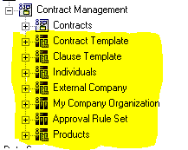
Figure 106 Folders with Role based security

Appendix G: Date Fields

All date fields are adjusted for the local time zone of the user. This is accomplished via the “USERTIMEZONE” database function. This function is automatically applied to standard date fields in the Cognos model so that they will match the Date / Time stamp seen by the user in IBM® EMPTORIS® CONTRACT MANAGEMENT.
This function is made available in the Cognos model under functions for report developers who want to apply it to custom fields in Terms and Lines.

Notices
This information was developed for products and services offered on a worldwide basis.
IBM may not offer the products, services, or features discussed in this document in other countries. Consult your local IBM representative for information on the products and services currently available in your area. Any reference to an IBM product, program, or service is not intended to state or imply that only that IBM product, program, or service may be used. Any functionally equivalent product, program, or service that does not infringe any IBM intellectual property right may be used instead. However, it is the user's responsibility to evaluate and verify the operation of any non-IBM product, program, or service.
IBM may have patents or pending patent applications covering subject matter described in this document. The furnishing of this document does not grant you any license to these patents. You can send license inquiries, in writing, to:
IBM Director of Licensing
IBM Corporation
North Castle Drive
Armonk, NY 10504-1785
U.S.A.
For license inquiries regarding double-byte character set (DBCS) information, contact the IBM Intellectual Property Department in your country or send inquiries, in writing, to:
Intellectual Property Licensing
Legal and Intellectual Property Law
IBM Japan Ltd.
1623-14, Shimotsuruma, Yamato-shi
Kanagawa 242-8502 Japan
The following paragraph does not apply to the United Kingdom or any other country where such provisions are inconsistent with local law: INTERNATIONAL BUSINESS MACHINES CORPORATION PROVIDES THIS PUBLICATION "AS IS" WITHOUT WARRANTY OF ANY KIND, EITHER EXPRESS OR IMPLIED, INCLUDING, BUT NOT LIMITED TO, THE IMPLIED WARRANTIES OF NON-INFRINGEMENT, MERCHANTABILITY OR FITNESS FOR A PARTICULAR PURPOSE. Some states do not allow disclaimer of express or implied warranties in certain transactions, therefore, this statement may not apply to you.
This information could include technical inaccuracies or typographical errors. Changes are periodically made to the information herein; these changes will be incorporated in new editions of the publication. IBM may make improvements and/or changes in the product(s) and/or the program(s) described in this publication at any time without notice.
Any references in this information to non-IBM Web sites are provided for convenience only and do not in any manner serve as an endorsement of those Web sites. The materials at those Web sites are not part of the materials for this IBM product and use of those Web sites is at your own risk.
IBM may use or distribute any of the information you supply in any way it believes appropriate without incurring any obligation to you.
Licensees of this program who want to have information about it for the purpose of enabling: (i) the exchange of information between independently created programs and other programs (including this one) and (ii) the mutual use of the information which has been exchanged, should contact:
IBM Corporation
Somers, NY
U.S.A
Such information may be available, subject to appropriate terms and conditions, including in some cases, payment of a fee.
The licensed program described in this document and all licensed material available for it are provided by IBM under terms of the IBM Customer Agreement, IBM International Program License Agreement or any equivalent agreement between us.
Any performance data contained herein was determined in a controlled environment. Therefore, the results obtained in other operating environments may vary significantly. Some measurements may have been made on development-level systems and there is no guarantee that these measurements will be the same on generally available systems. Furthermore, some measurements may have been estimated through extrapolation. Actual results may vary. Users of this document should verify the applicable data for their specific environment.
Information concerning non-IBM products was obtained from the suppliers of those products, their published announcements or other publicly available sources. IBM has not tested those products and cannot confirm the accuracy of performance, compatibility or any other claims related to non-IBM products. Questions on the capabilities of non-IBM products should be addressed to the suppliers of those products.
All statements regarding IBM's future direction or intent are subject to change or withdrawal without notice, and represent goals and objectives only.
This information contains examples of data and reports used in daily business operations. To illustrate them as completely as possible, the examples include the names of individuals, companies, brands, and products. All of these names are fictitious and any similarity to the names and addresses used by an actual business enterprise is entirely coincidental.

Trademarks
IBM, the IBM logo, and ibm.com are trademarks of International Business Machines Corp., registered in many jurisdictions worldwide. Other product and service names might be trademarks of IBM or other companies. A current list of IBM trademarks is available on the Web at "Copyright and trademark information" at www.ibm.com/legal/copytrade.shtml.
Emptoris®, EMPTORIS® and device, RIVERMINE®, and XCITEC® and device are trademarks or registered trademarks of IBM Corporation.
Adobe, the Adobe logo, PostScript, and the PostScript logo are either registered trademarks or trademarks of Adobe Systems Incorporated in the United States, and/or other countries.
Linux is a registered trademark of Linus Torvalds in the United States, other countries, or both.
Microsoft, Windows, Windows NT, and the Windows logo are trademarks of Microsoft Corporation in the United States, other countries, or both.
UNIX is a registered trademark of The Open Group in the United States and other countries.
Java and all Java-based trademarks and logos are trademarks or registered trademarks of Oracle and/or its affiliates.
Privacy Policy Considerations
IBM Software products, including software as a service solution, (“Software Offerings”) may use cookies or other technologies to collect product usage information, to help improve the end user experience, to tailor interactions with the end user or for other purposes.
Depending upon the configurations deployed, this Software Offering may use session and persistent cookies that collect each user’s name, profile name for purposes of session management, authentication, enhanced user usability, single sign-on configuration or other usage tracking or functional purposes. These cookies can be disabled, but disabling them will also eliminate the functionality they enable.
If the configurations deployed for this Software Offering provide you as customer the ability to collect personally identifiable information from end users via cookies and other technologies, you should seek your own legal advice about any laws applicable to such data collection, including any requirements for notice and consent.
For more information about the use of various technologies, including cookies, for these purposes, See IBM’s Privacy Policy at http://www.ibm.com/privacy and IBM’s Online Privacy Statement at http://www.ibm.com/privacy/details the section entitled “Cookies, Web Beacons and Other Technologies” and the “IBM Software Products and Software-as-a-Service Privacy Statement” at http://www.ibm.com/software/info/product-privacy.
Updated Appendix F Security. 2/5/2014
LIST OF FIGURES

Figure 1 Contract Management reporting starting page 10
Figure 2 Reporting tabs 10
Figure 3 Public folders 10
Figure 4 Presentation layer 18
Figure 5 Contracts query subject 19
Figure 6 Contract query subject data items (1) 20
Figure 7 Contract query subject data items (2) 20
Figure 8 additional query subjects 21
Figure 9 External party query subject 21
Figure 10 Contract Lines Extension (Line items as columns) 22
Figure 11 Contract Fact Star 24
Figure 12 Translation table structure 25
Figure 13 Translated items for filtering and reporting 25
Figure 14 Presentation layer structure 26
Figure 16 Data items in Contract fact table 27
Figure 17 Data items in clause fact table 28
Figure 18 Contract fact table with dimensions 29
Figure 19 Contract dimension 30
Figure 20 Contract template dimension 30
Figure 21 Contract created from dimension 30
Figure 22 Contract class dimension 31
Figure 23 Contract status dimension 31
Figure 24 Contract sub-status dimension 31
Figure 25 Contract nature dimension 32
Figure 26 Contract currency dimension 32
Figure 27 Contract origin dimension 32
Figure 28 Contract region dimension 33
Figure 29 Contract origin variant dimension 33
Figure 30 Contract timezone dimension 33
Figure 31 Contract dates 34
Figure 32 Organization dimension 35
Figure 33 Individual dimension 36
Figure 34 External primary contact 37
Figure 35 Contract Negotiation Status 38
Figure 36 Contract approval status 38
Figure 37 Boolean 38
Figure 38 Contract created by dimension 38
Figure 39 Contract modified by dimension 38
Figure 40 Contract interview dimension 39
Figure 41 Contract interview template dmension 39
Figure 42 Contract converted by dimension 39
Figure 43 Contract state dimension 40
Figure 44 Contract execution state dimension 40
Figure 45 Contract termination reason dimension 40
Figure 46 Contract created from template dimension 40
Figure 47 Independent subject areas 41
Figure 48 Contract Template Database layer 42
Figure 49 Contract Template 42
Figure 50 Clause Template Database layer 43
Figure 51 Clause Template 43
Figure 52 Individuals database layer 44
Figure 53 Individuals 45
Figure 54 External Company database layer 46
Figure 55 External Company 47
Figure 56 My Company 48
Figure 57 Approval Rule Set Database layer 49
Figure 58 Approval Rule Set 49
Figure 59 Products Database Layer 50
Figure 60 Products 51
Figure 61 < Insert caption text here> 52
Figure 62 Affiliated Organization Database layer 53
Figure 63 Affiliated Organization 53
Figure 64 Custom Properties Database layer 54
Figure 65 Custom properties 54
Figure 66 Organization fact database layer 55
Figure 67 External party 56
Figure 68 Contract Clause 57
Figure 69 Contract term database layer 58
Figure 70 Contract term 58
Figure 71 Contract Attachment database layer 59
Figure 72 Contract attachment 60
Figure 73 Contract Activity database layer 61
Figure 74 Contract Activity 62
Figure 75 Contract workflow 63
Figure 76 Contract Events database layer 64
Figure 77 Contract events 65
Figure 78 Contract Relationship database layer 66
Figure 79 Contract relationship 67
Figure 80 Contract sub-status database layer 67
Figure 81 Contract substatus 68
Figure 82 Contract Comments database layer 69
Figure 83 Contract Comments 70
Figure 84 Contract task database layer 71
Figure 85 Contract task 72
Figure 86 Contract security database layer 73
Figure 87 Contract security 73
Figure 88 Contract Signatories database layer 74
Figure 89 Contract Signatories 74
Figure 90 Contract Folders database layer 75
Figure 91 Contract folders 75
Figure 92 Contract Lines database layer 76
Figure 93 Contract Lines 77
Figure 94 Contract lines (continued) 78
Figure 95 Contract Line extension database layer 78
Figure 96 Report studio report types 81
Figure 97 Terms as rows: Selecting term type 81
Figure 98 Filter Button 82
Figure 99 Filter dialog box 82
Figure 100 Data Item properties 83
Figure 101 Data Item properties (Continued) 83
Figure 102 Custom Lines ETL operation diagram 84
Figure 103 Building new Time item (Step1) 85
Figure 104 Building new time item (Step 2) 85
Figure 105 Indexed items 90
Figure 106 Folders with Role based security 96

