How to collect MegaRaid Manager system debug logs

In order to understand what problems have been encountered in the system related with your RAID card you will need to use LSI System Data Collection Scripts to collect the MegaRaid Manager debug logs. After gathering the logs please send the files to VIVOTEK Technical Support so that they can analyze them. To use the scripts please follow the next steps:

- Download the LSI scripts from the following link:
ftp:// tsupport: tsupport@ ftp0.broadcom.com/outgoing_perm/CaptureScripts/lsigetwin_latest.zip

user: tsupport
password: tsupport
- Extract and copy the lsiget files in a convenient location. For example:
“C:\Users\vivotek\Documents”
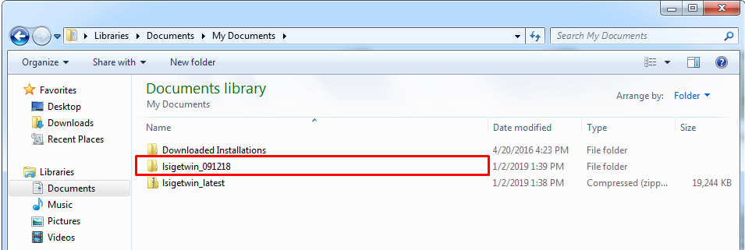
- Access the extracted folder and in the address bar, in front of the file name type “cmd.exe”
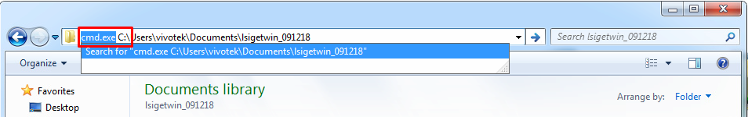
Opening the following window:
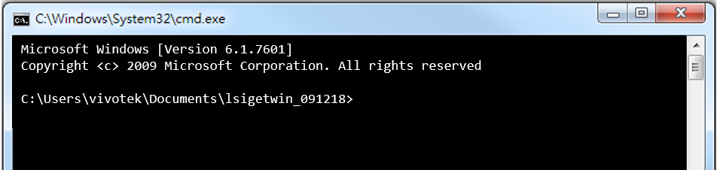
Note: you can also open the cmd.exe and then access the file by using the cd command as follows:
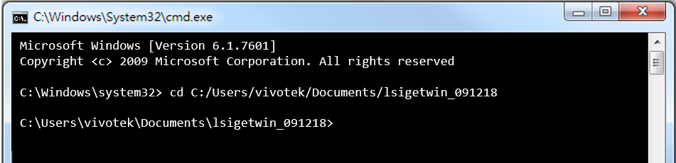
- Use the following command to run to script and then press <Enter>:
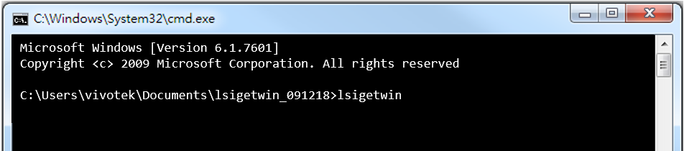
- The tool will automatically start to gather logs:
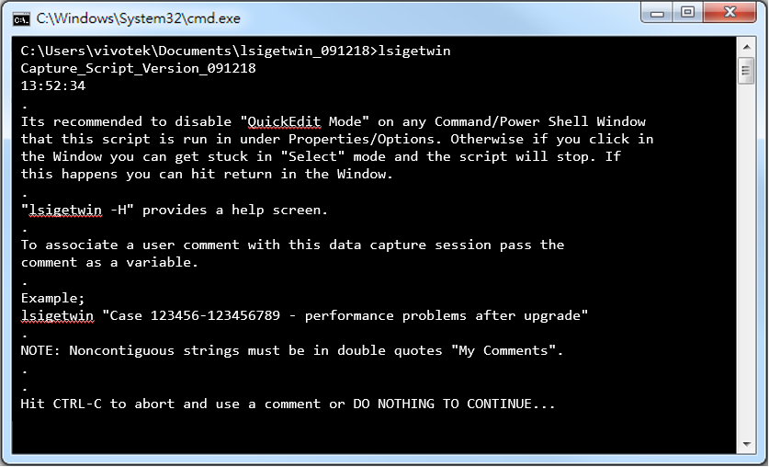
Note: a small window will pop up as follows:
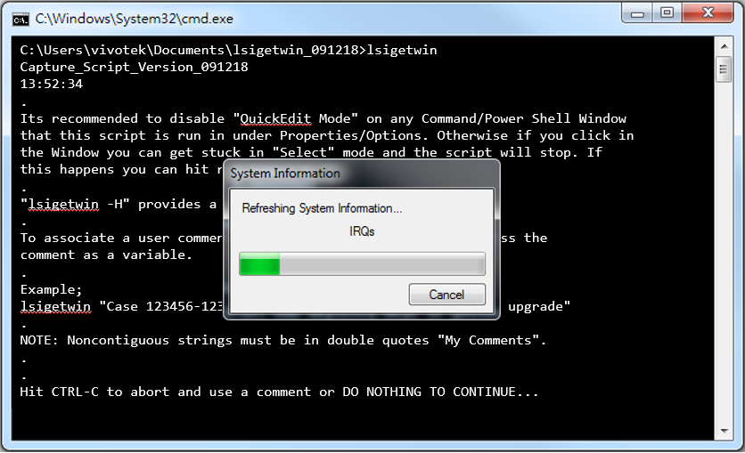
This is just to let you know that the system information is being collected. The collecting process will take around 3~4 minutes. When finished it will show the following message:
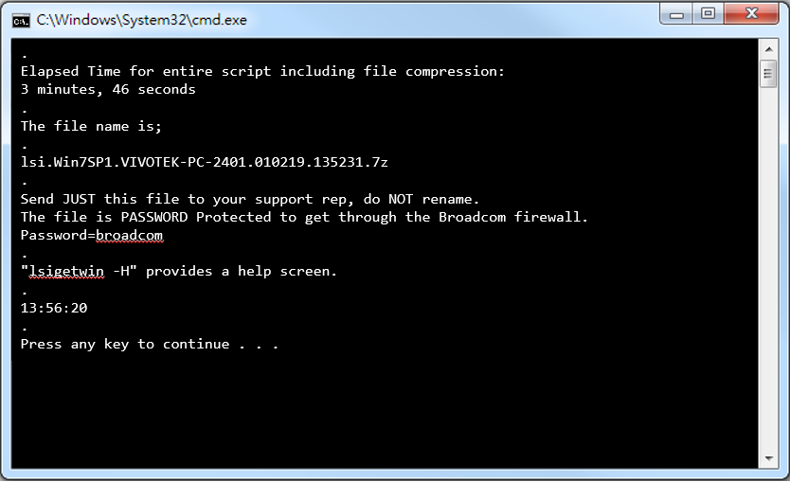
- After finishing collecting the logs, the tool will generate a file that will be stored in the same folder as the script.
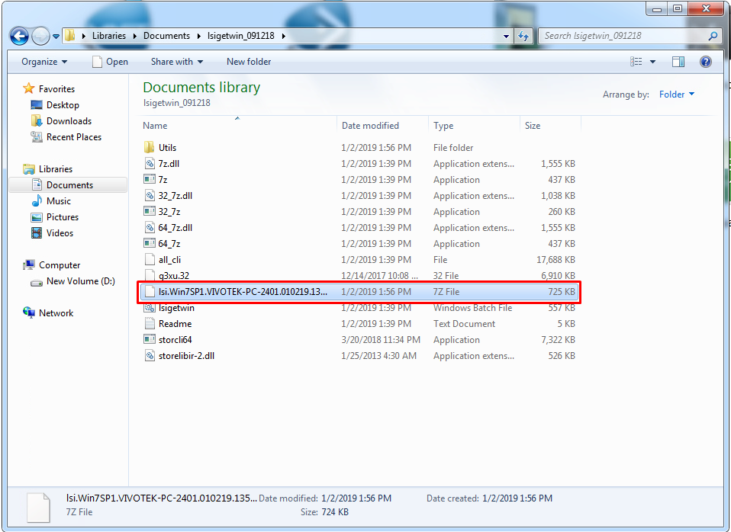
- Copy the file and send it to Technical Support (technical@vivotek.com) for analysis.

