How to collect MegaRaid Manager system logs
The MegaRaid Storage Manager stores logs that contain the status of the HDD, volumes and the RAID card itself. These logs can be helpful for VIVOTEK Technical Support for analyising a problem, so in order to resolve an issue please download these logs by following follow the next steps:

- Open the application by clicking on the “Raid Config” in the Control Center of the NR9X81
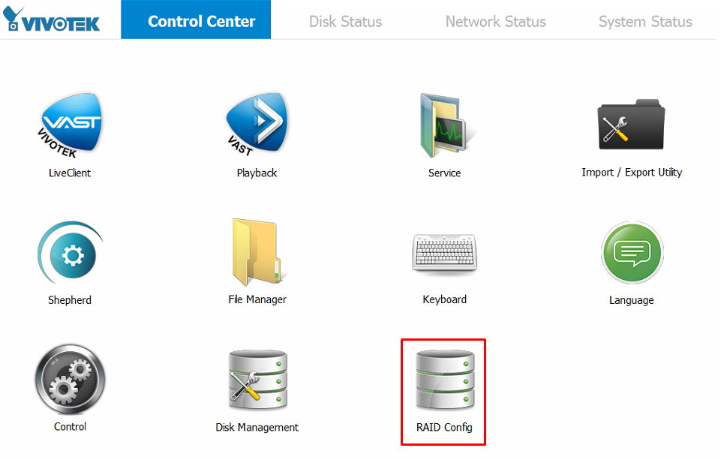
- Select your host (should be listed as below) then click the login button.
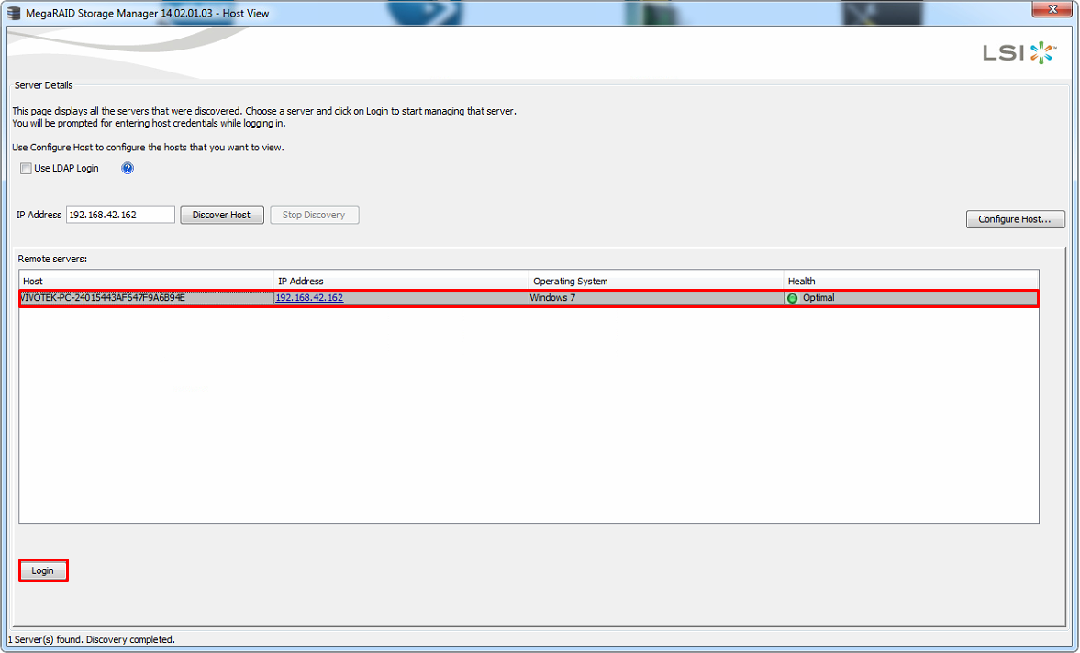
- In the login window use the username as “vivotek” and leave the password in blank. Note: if you set a password for the Windows OS you will need to use it in order to access.
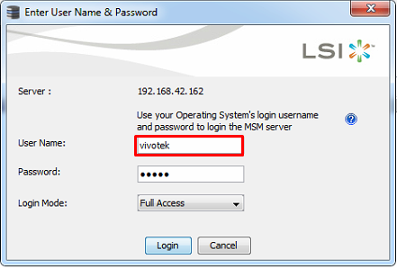
- In the MegaRaid Sotrage Manger go to Log and click on “Save as Text” to collect the MegaRaid Sotrage Manger syslog
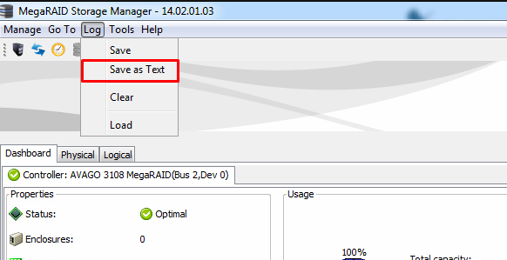
- Go to the Physical tab and select the RAID Volume configured
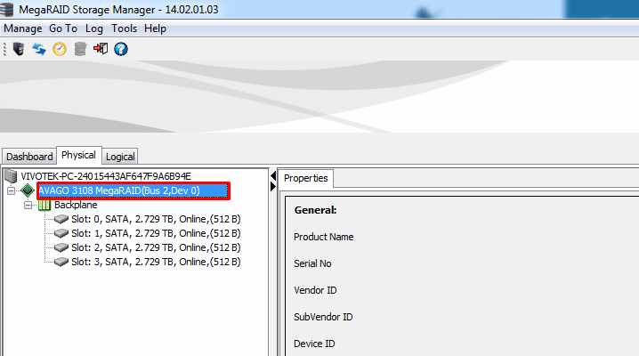
- Then right click on it and select the “Save TTY log” to save the volume internal logs.
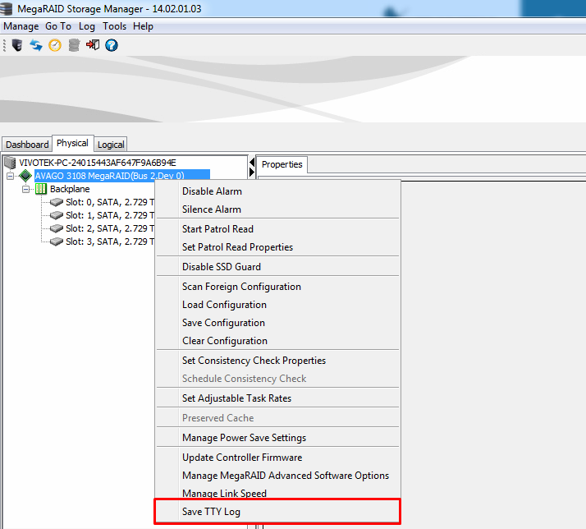
- Copy the logs and send them to Technical Support (technical@vivotek.com) for analysis.
